Estimates of SBT catch by CCSBT non-cooperating non-member states between 2007 and 2017

Prepared for the 24th Meeting of the CCSBT Extended Scientific Committee (ESC24) by Fisheries New Zealand, Ministry for Primary Industries, New Zealand

SUPPLEMENTARY MATERIAL

March 2020

Executive summary
Charles Edwards¹, Mahdi Parsa², Ashley Williams², Simon Hoyle³
1: CEscape Consultancy Services, Otaki, New Zealand; 2: Australian Bureau of Agricultural and Resource Economics and Sciences, Department of Agriculture, Water and Environment, Canberra ACT, Australia; 3: National Institute of Water and Atmospheric Research, Port Nelson, New Zealand.

Following submission of CCSBT-ESC/1909/33 (ESC24), by Edwards et al. (2019), the Extended Scientific Committee noted that catch estimates had substantially increased and requested that the following be considered for inclusion in further analyses:
- A quantitative evaluation of the relative impacts of the main data changes on the results
- A revision of the method for estimating the average weight of fish to account for the different weights of discarded and retained individuals
This supplement to the report fulfils these requests. First, it addresses each of the changes to the analysis that have occurred since presentation of CCSBT-ESC/1609/BGD02/Rev.1 (ESC21) by Edwards et al. (2016) and quantifies their impact on the final estimates of catches by non-cooperating non-members of CCSBT. Second, it updates the current analysis to include a re-calculation of the average weight per fish for Japanese catches, distinguishing between discarded and retained individuals.
Results showed that changes to the code used in processing the IOTC effort data have had the most substantial impact, increasing the predicted average catch for the Indian/Atlantic Oceans by 70 to 500 tonnes, with the range bounded by whether Taiwanese or Japanese catchability is assumed for the non-member effort. This indicates that catches estimated in 2016 have increased by 500 - 900% due to this single change to the analysis, which was by the far the most significant effect detected. In the Pacific Ocean, changes were much smaller, with the most notable being an increase of around 20 - 70% (1 - 20 tonnes more) as a result of changes to the WCPFC effort data, and a decrease of 20% (around 20 tonnes less) as a result of changes to the Japanese CCSBT data extract. The effect of changing the weight estimation for Japanese catches led to a small decrease in the predicted catch rates for Japan, with no noticeable consequences for the prediction of non-member catches.

Introduction
This supplement to CCSBT-ESC/1909/33 (ESC24) fulfils two requirements. Under Objective 1, it examines changes to the analysis that have occurred since presentation of CCSBT-ESC/1609/BGD02/Rev.1 (ESC21) in 2016 and quantifies their impact on the results. Under Objective 2, it updates the calculation of catch weights by the Japanese fleet, to account for differences between the average weights of individual fish that are retained or discarded. Objective 1 can therefore be considered a validation of the approach, whilst Objective 2 is a further refinement of the methods. Each of these is considered separately. Throughout, we refer to CCSBT-ESC/1609/BGD02/Rev.1 (ESC21) and CCSBT-ESC/1909/33 (ESC24) as the “2016” and “2019” analyses respectively.

Evaluation of the effect of changes to the data and analysis
Since CCSBT-ESC/1609/BGD02/Rev.1 (ESC21), changes to the data and analyses may have affected either or both of: the estimation of CCSBT catch rates; the scaling of the catch rates by non-member effort.
Changes that may have affected estimation of the CCSBT catch rates include:
- Revision of the JP CCSBT catch and effort data: components of the CCSBT database used in previous iterations of the work were discarded for the 2019 analysis following consultation with the CCSBT Secretariat.
- Revision of the ZA CCSBT catch and effort data: ZA now submit all their effort data. In previous iterations the effort data were incomplete.
- Removal of catch rate outliers for data from AU and ZA.
- Revision to the WCPFC effort data: WCPFC data were obtained directly from the CCSBT for the 2019 analysis. In previous iterations only publicly available (incomplete) data were available to be used.
- Revision of the IOTC effort data: Previous processing of the IOTC data misallocated the effort spatially which has now been corrected in the code.
- Changes to the model: the covariates used for the GLM were changed in 2019 so as to better fit the data (covariates for the RF remained the same).
Revision to the WCPFC and IOTC effort data is listed because it will have affected calculation of the “adjusted” CCSBT effort and therefore the catch rates for JP, KR and TW (noting that it is only for these flag states that the adjustment is considered necessary due to the potential under-reporting of zero-catch effort; CCSBT-ESC/1609/BGD02/Rev.1). The WCPFC data used in the 2016 analysis is only available up to 2014 inclusive. Similarly for the previous iteration of the ZA CCSBT data.
Changes that may have affected scaling of the CCSBT catch rates include:
- Revision of the WCFPC effort data (as described above).
- Revision of the IOTC effort data (as described above).
Revisions to the WCPFC and IOTC data will have led to changes in both the total effort and the spatial distribution in effort and will therefore have affected estimation of the total catches by non-members.
To quantitatively evaluate the contribution of each of these changes to the analysis, the current (2019) analysis was repeated with each of the data revisions listed in Table 1. Each revision constitutes a single (“backwards”) change to the analysis relative to a reference model run. A bilateral comparison with the reference then allows the marginal effect of the change to be quantified. For example, if a revised analysis predicts a reduced non-member catch relative to the reference, we can conclude that the specific change to the analysis made between 2016 and 2019 will have led to an increase in the predicted catch. Two reference cases were used depending on the range of years considered:
- Reference Case A: Identical to that presented in CCSBT-ESC/1909/33
- Reference Case B: Identical to that presented in CCSBT-ESC/1909/33 with the exceptions that model covariates for the GLM matched those used in 2016 and the analysis terminated in 2014.
Comparing model runs to one of these reference cases, each of the six revisions listed above were analysed independently and are reported in approximate order of importance.

Change to the estimation of catch weights for Japan
The empirical catch weight for JP (used for model fitting) is estimated from an average weight prediction per strata multiplied by the numbers recorded as caught. Currently the numbers discarded and retained are summed before multiplication by the average weight. For Objective 2, we re-processed data for the JP fleet so that total catches were estimated as:
Catch (kg) = Numbers Retained x predicted weight (kg) + Numbers Discarded x 18 kg
This alternative model run is also listed in Table 1. Results were compared to the “Current Analysis” in a manner similar to the outputs listed under Objective 1.

Results

Evaluation of the effect of changes to the data and analysis
For each evaluated revision, a single component of the analysis was changed back to how it was performed in 2016. Comparison with the complete 2019 analysis then allowed us to infer the magnitude of the effect of that revision.
The total estimated catches are listed in Table 2 to Table 9 (see also Figure 18 to Figure 25), with changes summarised in Table 10 and Table 11. Change to the processing of the IOTC data had by far the greatest effect on the results: revision of the IOTC data, with all other changes accounted for, led to a more than six-fold increase in the non-member catch from the Indian/Atlantic Oceans between 2007 and 2017 (Table 10). This result was consistent across surrogate flags (JP and TW), and estimation methods (GLM or Random Forest). In the Pacific, the biggest changes were the result of updates to the WCFPC data, which led to a 20% to 70% increase in the predicted catches and, for the JP surrogate flag only, changes to the CCSBT extract of JP data, which led to a 20% decrease in the predicted catches (Table 11). Other smaller changes to the predictions were recorded and will be discussed in turn.
We note that there is some stochasticity implicit in the estimation of the catches. Specifically, estimation of the catch biomass for the JP fleet involves subsampling of the JP length frequency data (Section 4.3.1 of CCSBT-ESC/1909/33). A second stochastic process, specific to the GLM, involves prediction of the catch rates using simulation of the residual distribution (Section 5.1.1 of CCSBT-ESC/1909/33). For the RF method, some stochasticity is involved in the sampling of trees when searching for the tree with the highest explanatory power. These will lead to small differences in the predicted catch rates even when methods are applied to the same data. Re-iteration of these processes is the reason behind small (approximately 2%) differences between the estimated catches listed for Reference Case A, compared to those presented in CCSBT-ESC/1909/33. This variability could be stabilised by increasing the number of iterations within each stochastic process but is noticeably much smaller than that observed from changes to the analysis being investigated in the current report.

Revision of the IOTC effort data (Model AR vs A1)
Changes to the code led to a southward shift in the spatial distribution of IOTC effort (Figure 1). Noting that all effort north of 20°S is removed (where SBT catches are assumed to be negligible), total IOTC effort used in the analysis increased by approximately 15% from 869 million hooks in 2016 to 999 million hooks in 2019. The total effort for non-members increased by 15% from 69 million hooks in 2016 to 79 million hooks in 2019. This in itself would be expected to substantially affect the predicted catches. However, in addition, non-member effort was shifted into regions of higher SBT catch rate, specifically regions 8 and 9 (see also Figure 23 in CCSBT-ESC/1909/33).
As well as increasing the total non-member effort, and the proportion of that effort in higher latitude regions, this change also affected calculation of the adjusted member catch rates. This secondary effect is relevant to the non-core strata, and for JP, KR and TW, since it is only for those strata and flags that an effort adjustment is implemented. Changes to the IOTC effort data have no effect on the raw or adjusted effort for core strata, as expected (Figure 2). However, the adjusted effort for non-core strata is changed (Figure 3). Specifically, the adjusted effort for non-core strata is reduced in proportion to a reduction in the IOTC effort. This reduction in the IOTC effort is because at higher latitudes effort has shifted into the core strata and is therefore not considered when implementing the adjustment. At lower latitudes there are some increases in the IOTC non-core effort, as effort is allocated to south of 20°S. However, positive changes to the adjusted CCSBT effort are less pronounced. This is because adjustment of the effort is predicated on there being recorded effort in the CCSBT database. If there is zero CCSBT effort recorded in a strata, then it remains at zero (i.e. no adjustment takes place). This is an assumption that could be revisited in future iterations. Overall, changes to the adjusted effort have led to an increase in the empirical catch rates, particularly for JP (Figure 4 and Figure 5).
The combined effect of these changes (to the non-member effort spatial distribution and to the adjusted CCSBT catch rate) is an increase in the predicted non-member catch per year for the Indian/Atlantic Oceans. This increase is of 70 - 500 tonnes on average across years, depending on whether TW or JP catchability is assumed for the non-member effort (Table 10). It represents an increase of 510 - 560% for the GLM method and 540 - 890% for the RF method, compared to the estimate from 2016. It was by far the most significant single effect detected and explains most of the difference in catches between ESC/1609/BGD02/Rev.1 (ESC21) and CCSBT-ESC/1909/33 (ESC24).

Revision of the WCPFC effort data (Model BR vs B1)
Changes to the WCPFC data extract (obtained directly from the CCSBT secretariat in 2019, rather than via the public domain) led to an increase in the overall effort available for the analysis. In a comparison over the 2007 to 2014 years only (since the 2016 data extraction process was not repeated to include the most recent years), total effort in the WCPFC data increased by 60% with the new data, from 338 million hooks in 2016 to 540 million hooks in 2019. For non-members specifically, there was an increase of 36% in the available effort: from 190 million hooks in 2016 to 258 million hooks in 2019. This increase was due simply to the completeness of the data from WCPFC that is now available.
The distribution of effort data shifted to the South West, into regions 5, 6 and 7 (see also Figure 20 in CCSBT-ESC/1909/33), which have higher raw catch rates (Figure 6). However, similar to the effect of changes to the IOTC data, the changed WCPFC effort will also affect the effort adjustment for non-core CCSBT data. The adjusted CCSBT effort for JP and TW is unchanged for the core strata (Figure 7) but has increased for non-core strata (Figure 8) in contrast to the effect of changed IOTC data in the Atlantic/Indian Oceans (Figure 3). The effect was to reduce the non-core, adjusted CCSBT catch rates (Figure 9 and Figure 10). As a consequence of these counteracting influences of the new data (higher non-member effort but lower member catch rates), the net effect of increased WCPFC effort in the Pacific is dampened but still noticeable (Table 11). Assuming TW catchability, and for the years 2007 to 2014, the total catches in the Pacific have increased by less than 1 tonne according to both GLM and RF methods. However, assuming JP catchability, the total non-member catches have increased by between 8 tonnes (for the GLM method) and 20 tonnes (for the RF method).

Revision of the JP CCSBT catch and effort data (Model AR vs A2)
In the 2019 extract of the JP catch and effort data from the CCSBT database, only one of the two available JP datasets was retained for downstream analysis – the one with the more complete effort coverage. Restriction to a dataset with a more complete effort record led to a reduction in the raw JP CCSBT catch rate. This is illustrated in Figure 11 and Appendix B of CCSBT-ESC/1909/33. Overall, this change led to a reduction in the predicted catches (Table 10 and Table 11). For example, the average catch in the Indian and Atlantic Oceans, assuming a JP catchability, reduced from 671 to 626 tonnes for the GLM method (Table 2, a drop of approximately 7%) as a result of that single change to the analysis (i.e. keeping all other components unchanged). For the RF method, the drop was approximately 5%, from 578 to 559 tonnes. Larger reductions were recorded in the Pacific, of approximately 20% for both GLM and RF methods and assuming a JP catchability (Table 6 and Table 8). As might be expected, the predictions made assuming a TW catchability are largely unchanged, since the raw TW catch rates were unaffected (Figure 11).

Changes to the model (Model AR vs A3)
Changes to the GLM were made for the 2019 analysis, so as to better fit the recent data; in particular the recent changes to the JP CPUE in both the Atlantic/Indian and Pacific Oceans. Figure 12 shows fits to the same (2019) catch rate data extract using both the 2016 and 2019 models. The previous model did not fit the JP catch data particularly well, but the fit is improved by the new model, tracking the 2015 increases in JP CPUE and subsequent decreases. This better fit to the data leads to changes in the predicted catch rates per year and non-member catches for the Atlantic/Indian and Pacific Oceans when assuming a JP catchability, but also to a less obvious extent when assuming the TW catchability (Table 10 and Table 11). We note that the RF model was unchanged between the 2016 and 2019 analyses, with any differences noted due to variation between independent tuning procedures.
For all oceans, assuming a JP catchability, the predicted catches for 2015 are increased by using the new model, since the model is able to better fit the high catch rates in that year. However, this has not necessarily led to an increase in the average catch between 2007 and 2017. For example, in the Pacific, adopting the new GLM increases the 2015 catch from 191 tonnes to 235 tonnes, but the average catch drops from 113 tonnes to 105 tonnes (with an average reduction across years of 5%, Table 6). In the Atlantic/Indian Ocean the 2015 catch increases from 730 to 900 tonnes, but the average catch changes only slightly, from 618 to 626 tonnes, and the average ratio decreases by 2% (Table 2). Fit of the 2019 model led to seemingly negligible changes in the TW catch rate predictions (Figure 12) but did result in changes in the predicted overall catches. In the Indian/Atlantic, assuming a TW catchability, changes to the model led to a reduction in the average predicted catches from 211 to 191 tonnes using the GLM (approximately 5%; Table 3) and from 95 to 84 tonnes using the RF approach (approximately 15%; Table 5).

Removal of catch rate outliers for CCSBT data from AU and ZA (Model AR vs A4)
A second modification to the analysis that was designed to allow better prediction of the catch rates, was to trim outlying (possibly influential) observations from the raw data. This consisted of a total of 8 catch records from Australia (5 in the Pacific and 3 in the Indian Oceans), and 6 catch records from South Africa (3 in the Atlantic and 3 in the Indian). The fit to the data was improved substantially following removal of these few records, particularly in the Pacific (Figure 13). However the overall effect on the catch rate estimation was small (Table 10 and Table 11).

Revision of the ZA CCSBT catch and effort data (Model BR vs B2)
Compared to the 2016 extract, South Africa now submit a more complete data set, including more of the zero-catch effort data. This change can be seen in Figure 14, which shows a substantial increase in the total effort between 2007 and 2014 (i.e. over the year range of the 2016 analysis), and a consequent drop in the catch rate. The effect of this change is limited to the Atlantic/Indian Ocean, since there is no South African fishing effort in the Pacific. However, given the low volume of South African fishing effort, the reduced ZA catch rate does not contribute noticeably to the estimation of the catch rates for either JP or TW, and the downstream effects on the total non-member catch are small.

Change to the estimation of catch weights for JP
In fulfilment of Objective 2, the conversion of catch numbers into weight for the JP fishery (see Section 4.3.1 in CCSBT-ESC/1909/33) was updated so that all discarded catches were assumed to be 18kg in weight, rather than using the predicted average individual weight from the statistical model fit. Maintaining all other components of the analysis identical to those presented in CCSBT-ESC/1909/33, this led to a small reduction in the average JP catch rates (Figure 15), which translated into a reduction in the predicted catches (Figure 16 and Figure 17). The total revised and updated non-member catches are listed in Table 12 and Table 13. Using the GLM method, the average 2007 – 2017 predicted non-member catch is 194 – 550 tonnes in the Indian/Atlantic Ocean and 8 – 98 tonnes in the Pacific. Using the RF method, the average non-member catch is 84 – 510 tonnes in the Indian/Atlantic Ocean, and 10 – 77 tonnes in the Pacific.

Discussion and Conclusions
A number of revisions occurred to the analysis between CCSBT-ESC/1609/BGD02/Rev.1 (ESC21) and CCSBT-ESC/1909/33 (ESC24), leading to a substantial increase in the predicted catches for non-cooperating non-members of the CCSBT. In this supplement, we have examined the marginal contributions made by each of these revisions. The most noticeable effect was from revised processing of the IOTC effort data, which led to substantial increase in the predicted catches from the Indian Ocean. Smaller changes have occurred as a result of revisions to the Japanese CCSBT data extract and, in the Pacific, as a result of revisions to the WCPFC data. All of these revisions represented an improvement on the 2016 analysis, including more complete and correctly processed datasets.
In addition, we updated the analysis so as to better estimate the weights for retained and discarded catches for the Japanese fleet. This additional improvement did not however lead to any noticeable alteration to the predicted catches, which remain at approximately 100 to 500 tonnes per year in the Indian/Atlantic Oceans and 10 to 100 tonnes in the Pacific (Table 12 and Table 13).

Acknowledgments
This work was funded by the Fisheries New Zealand (Project code SEA2019-17), and the Australian Bureau of Agricultural and Resource Economics and Sciences’ Fisheries Resources Research Fund.

Figures

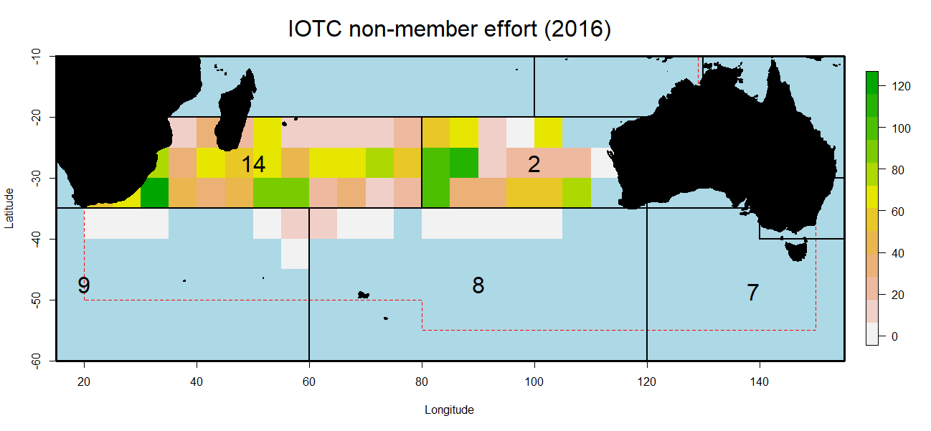

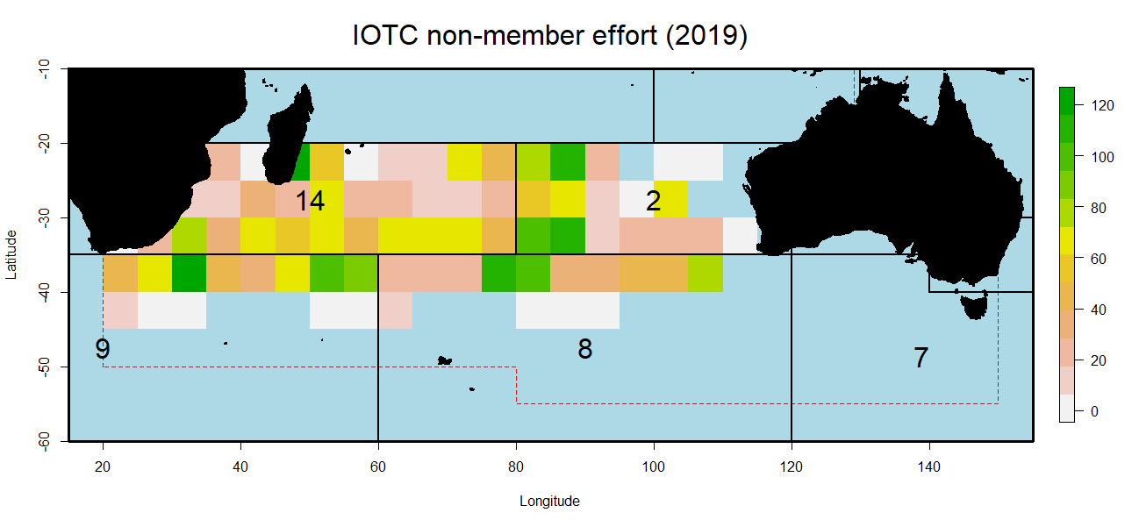
Figure 1. Raw IOTC effort distributions in the 2016 (CCSBT-ESC/1609/BGD02/Rev.1) and 2019 (CCSBT-ESC/1909/33) analyses, shown as a mean across quarters from 2007 to 2017 in units of 1000 hooks. Note the translation of effort south into the higher latitudes following revision of the code. All effort north of 20ºS was discarded.

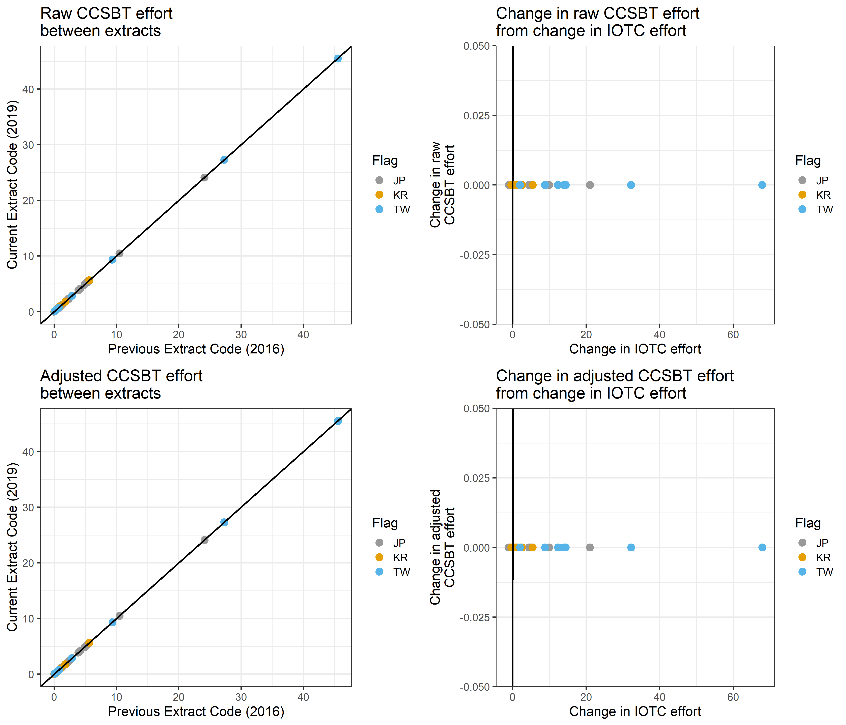
Figure 2. Change in CCSBT effort in relation to change in IOTC effort (core strata). Effort is summed per grid and given in units of million hooks. For core strata the raw and adjusted CCSBT for the current and previous extracts are identical (left column). The CCSBT effort is unchanged given changes in the IOTC effort (right column).

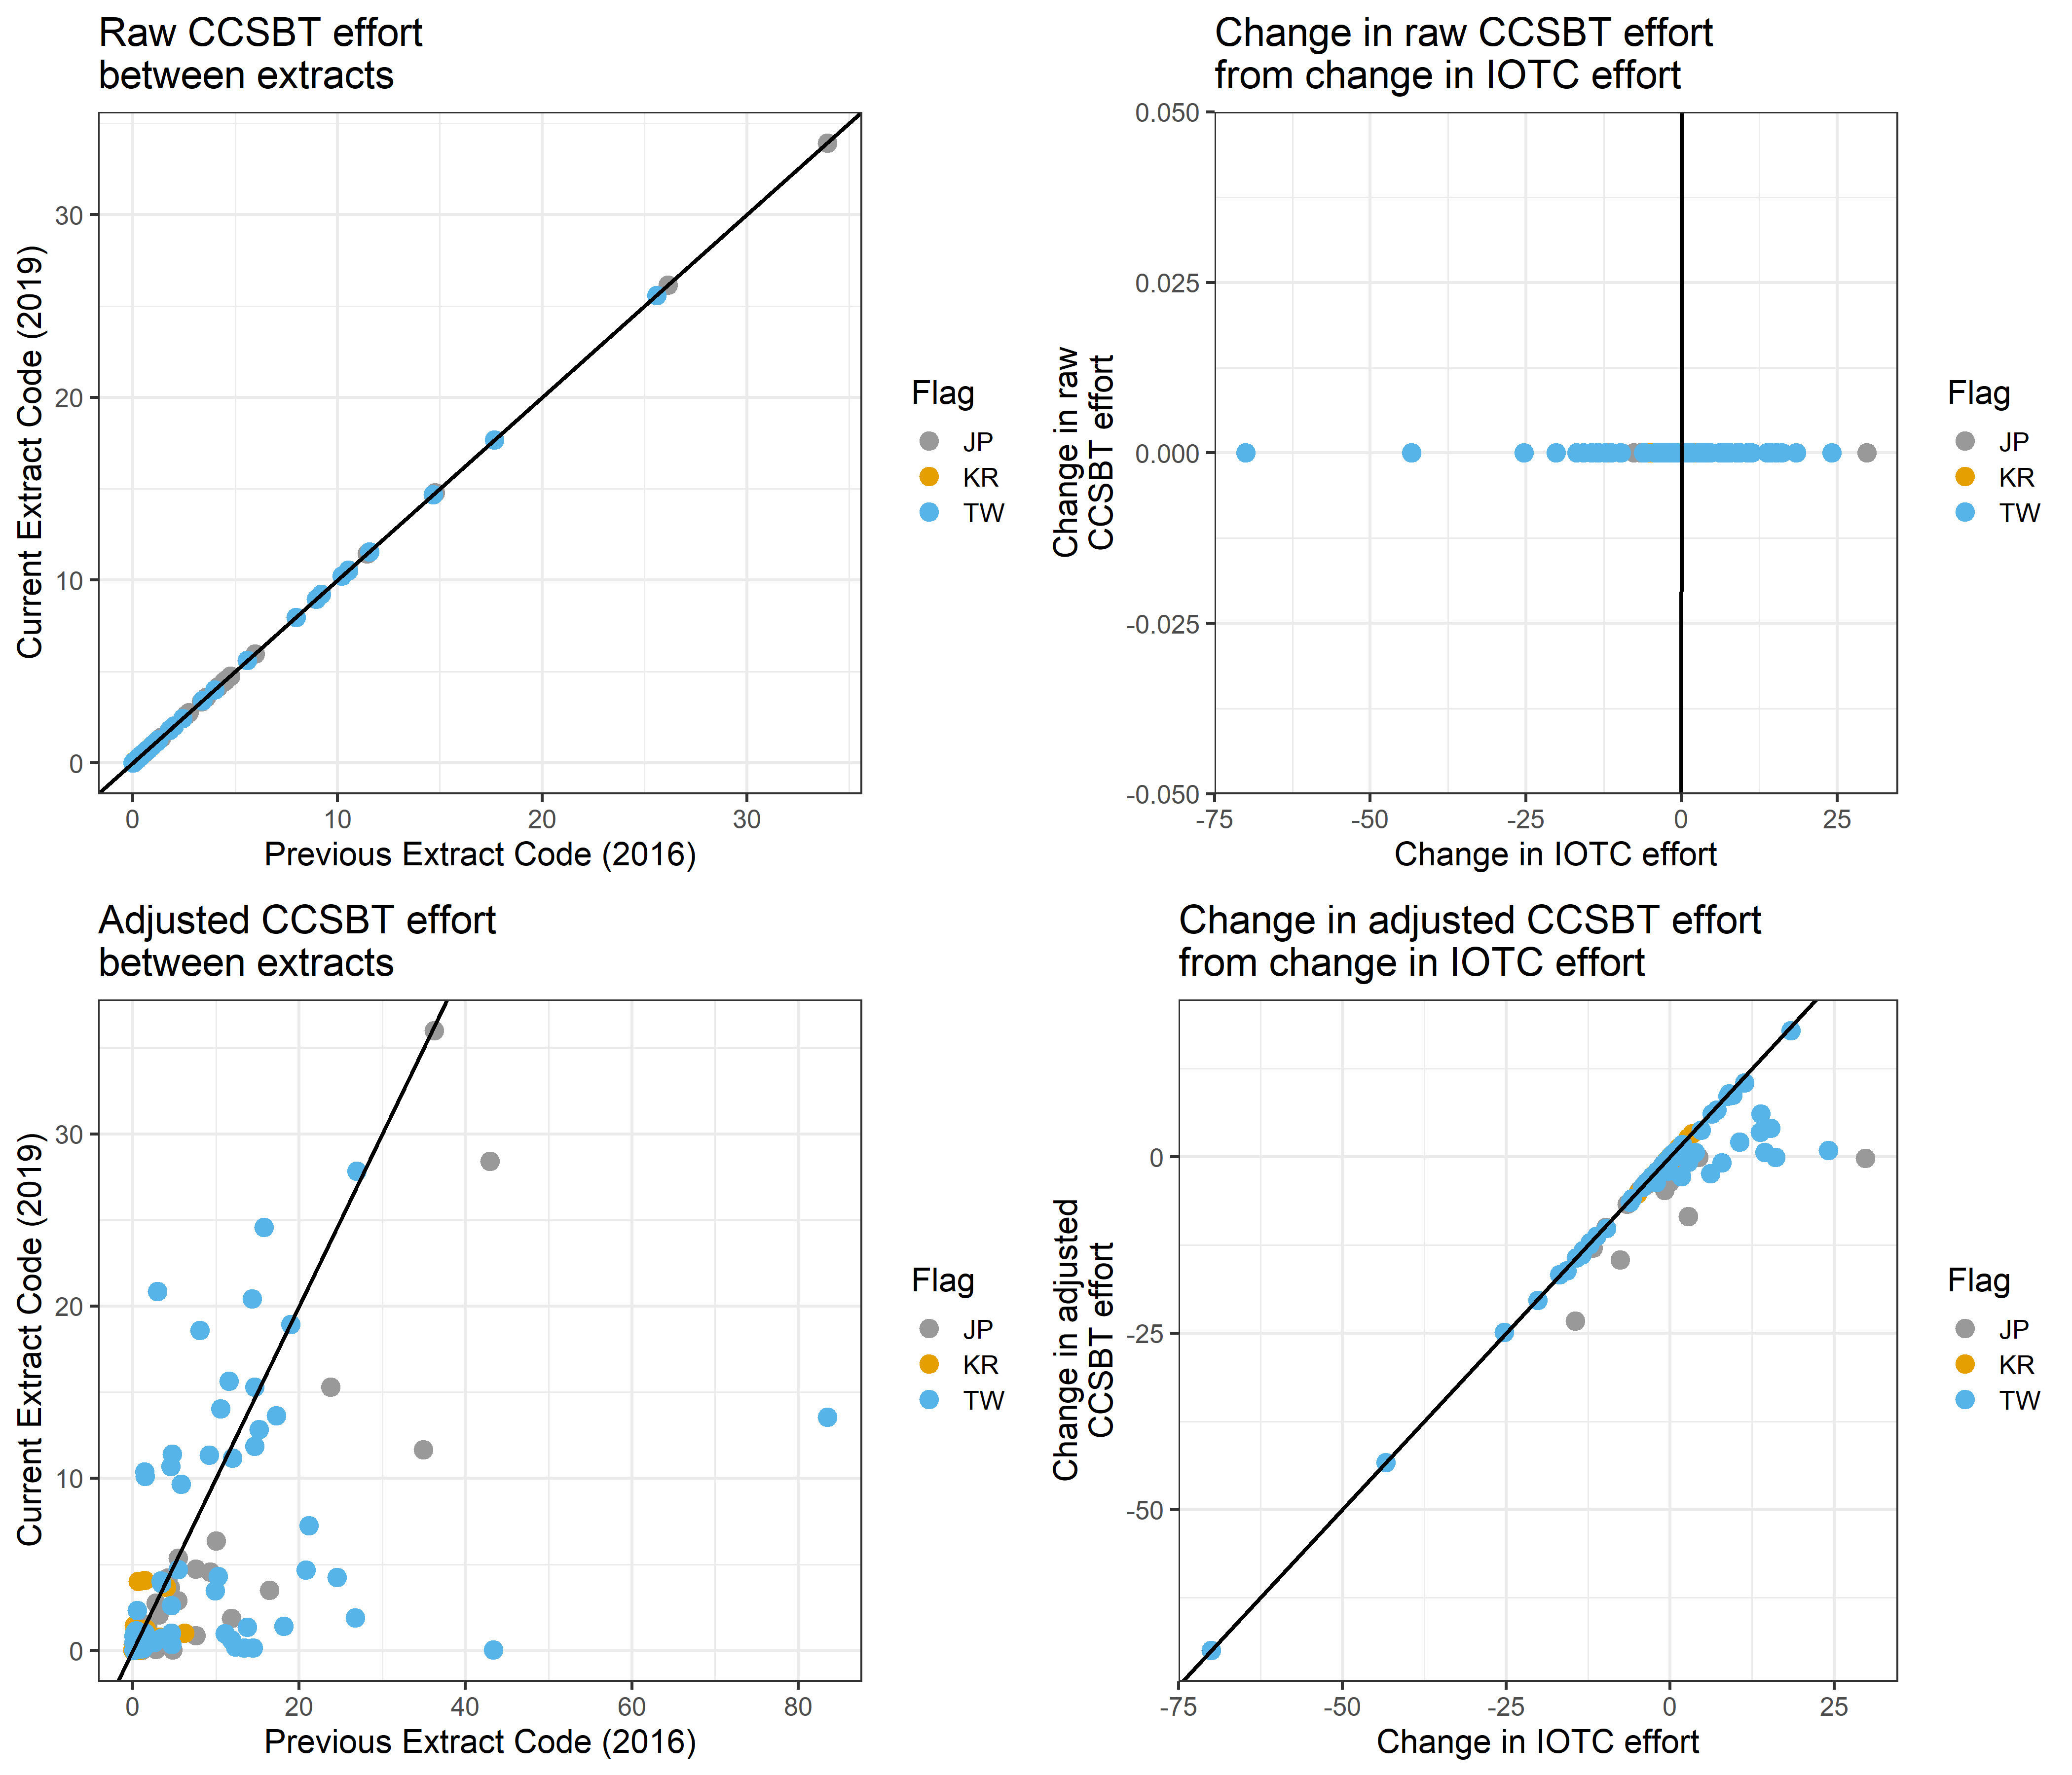
Figure 3. Change in CCSBT effort in relation to change in IOTC effort (non-core strata). Effort is summed per grid and given in units of million hooks. For non-core strata the raw CCSBT effort is unchanged but the adjusted effort is updated (left column). Changes to the IOTC effort in non-core strata leads to changes in the adjusted CCSBT effort (right column). A positive change indicates that the effort has increased from the previous extract (2016) to the current extract (2019).

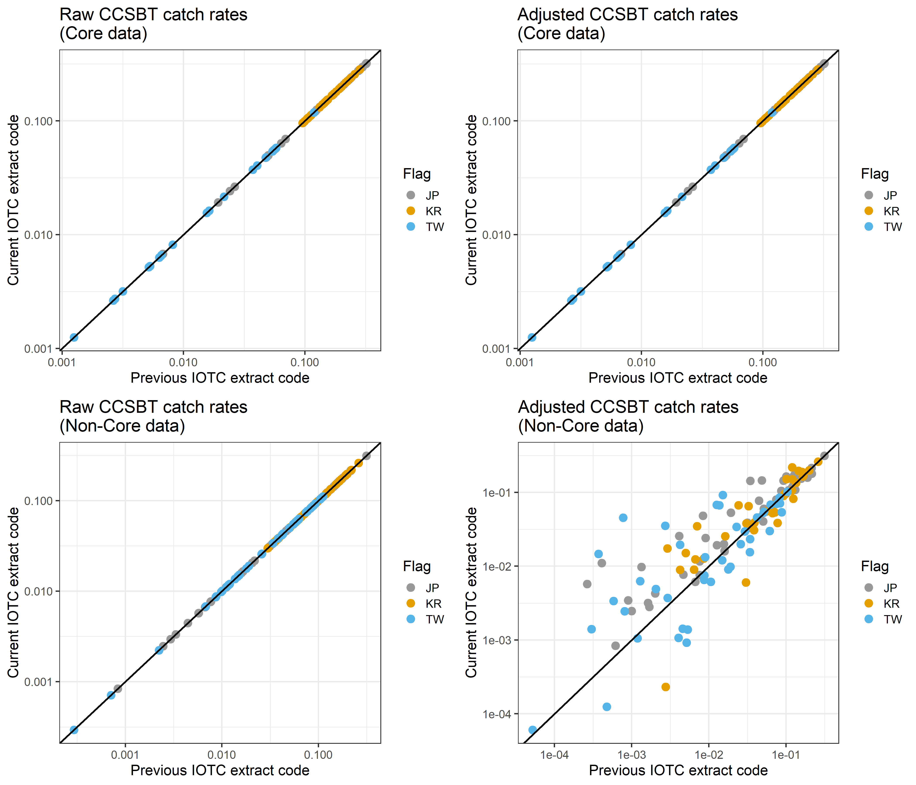

Figure 4. Changes to the raw and adjusted CCSBT catch rates (in average kg per hook per grid) as a result of changes to the IOTC effort data extract. Only JP, KR and TW are shown, since catch rates from other flags are not adjusted.

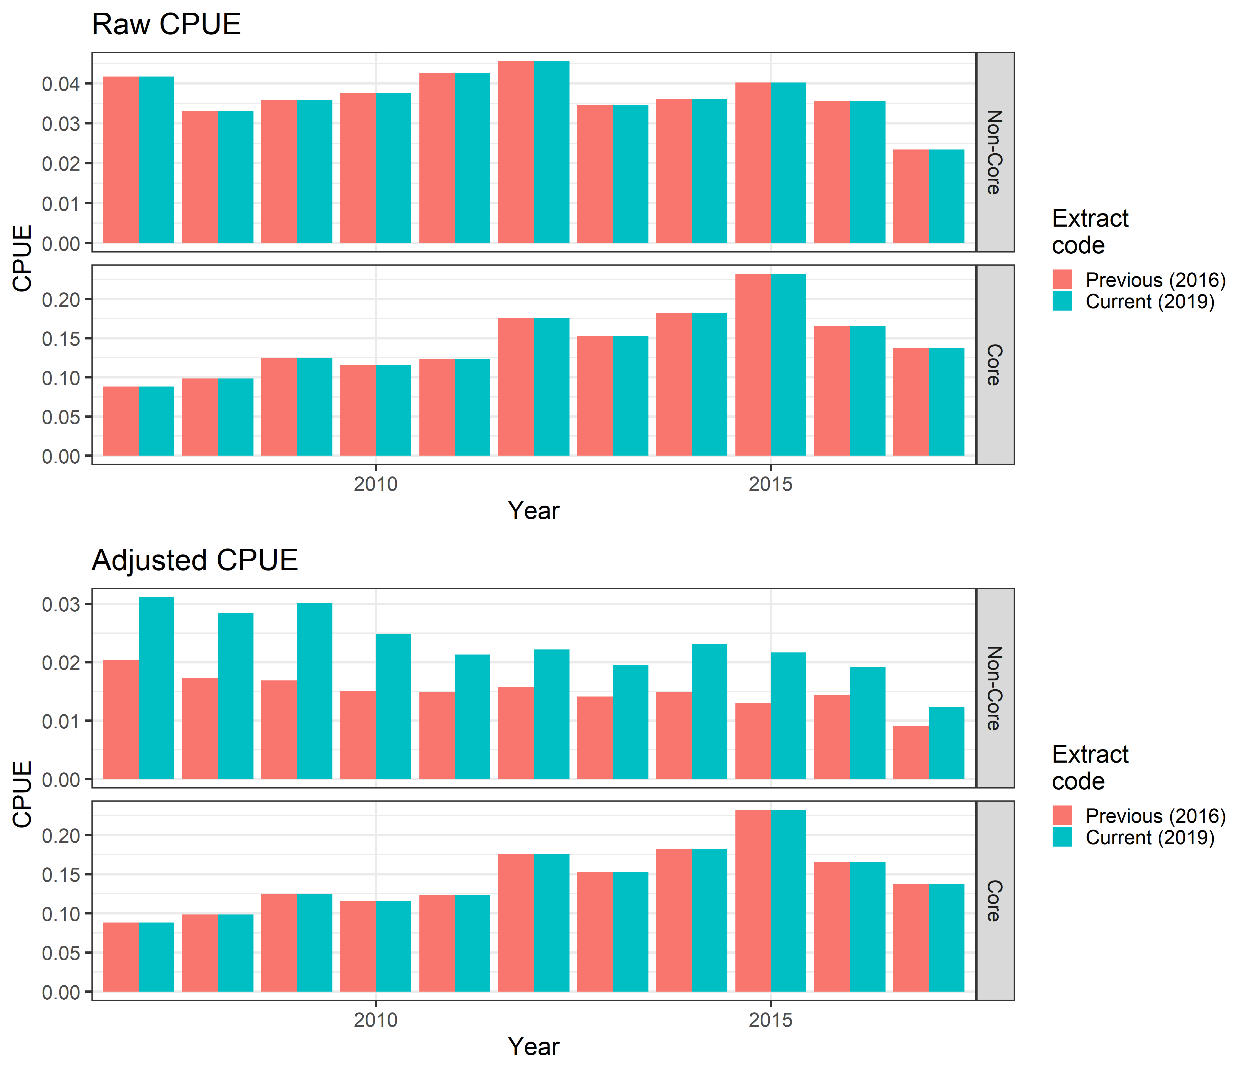
Figure 5. Overall effect of changes to the IOTC effort data on the average empirical catch rates in kg per hook for JP, TW and KR. The adjusted CPUE for non-core strata has increased as a result of changes to the IOTC data extract. The previous (2016) extract code refers to that used for CCSBT-ESC/1609/BGD02/Rev.1, the current (2019) extract code refers to that for CCSBT-ESC/1909/33.

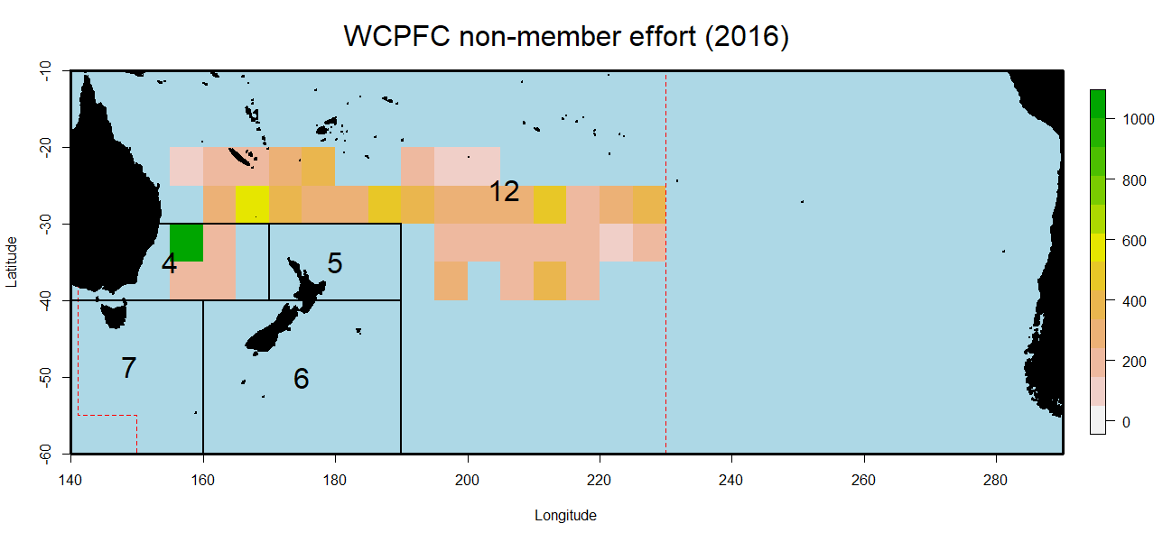
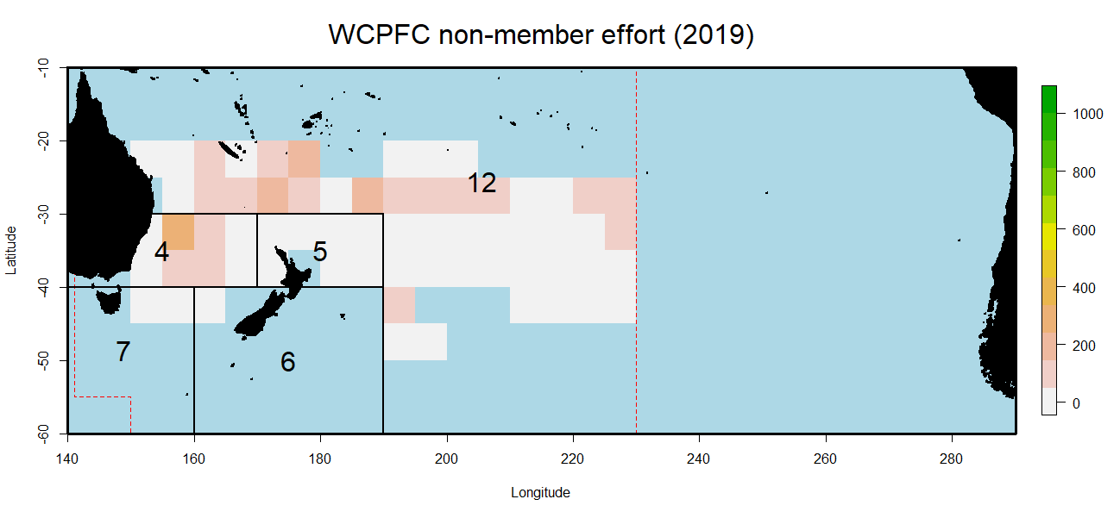
Figure 6. Raw WCPFC effort distributions in the 2016 (CCSBT-ESC/1609/BGD02/Rev.1) and 2019 (CCSBT-ESC/1909/33) analyses, shown as a mean across quarters from 2007 to 2014 in units of 1000 hooks. Note the translation of effort South West. All effort north of 20ºS was discarded.

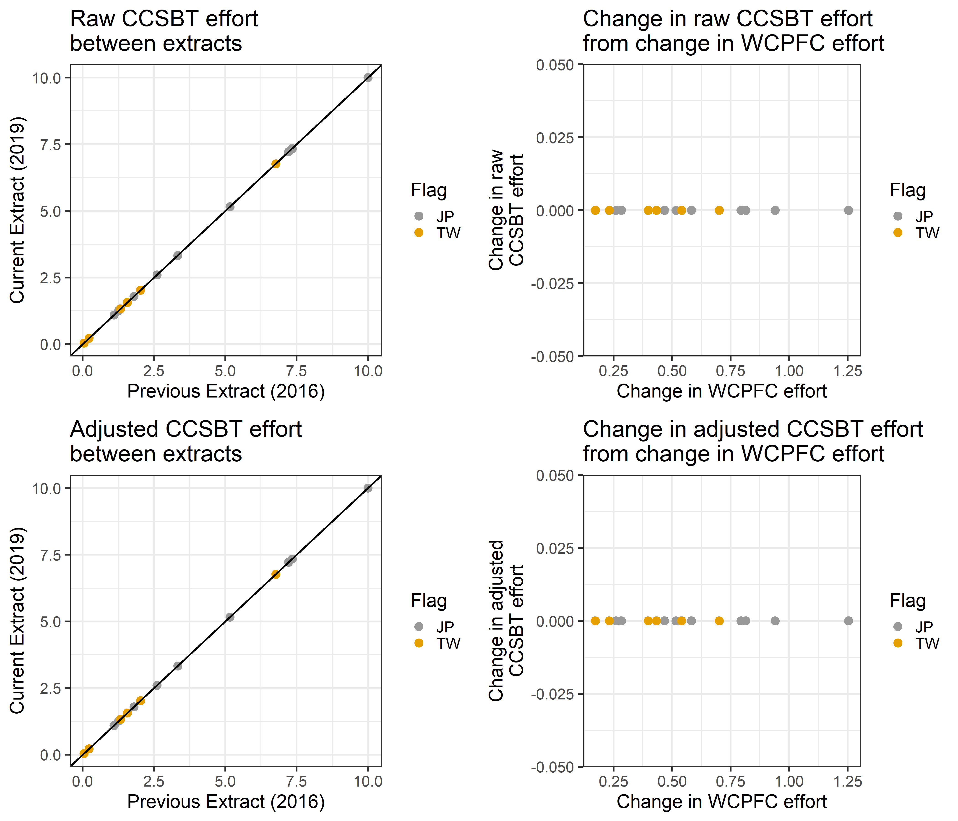
Figure 7. Change in CCSBT effort in relation to change in WCPFC effort (core strata). Effort is summed per grid and given in units of million hooks. For core strata the raw and adjusted CCSBT for the current and previous extracts are identical (left column). The CCSBT effort is unchanged given changes in the WCPFC effort (right column).

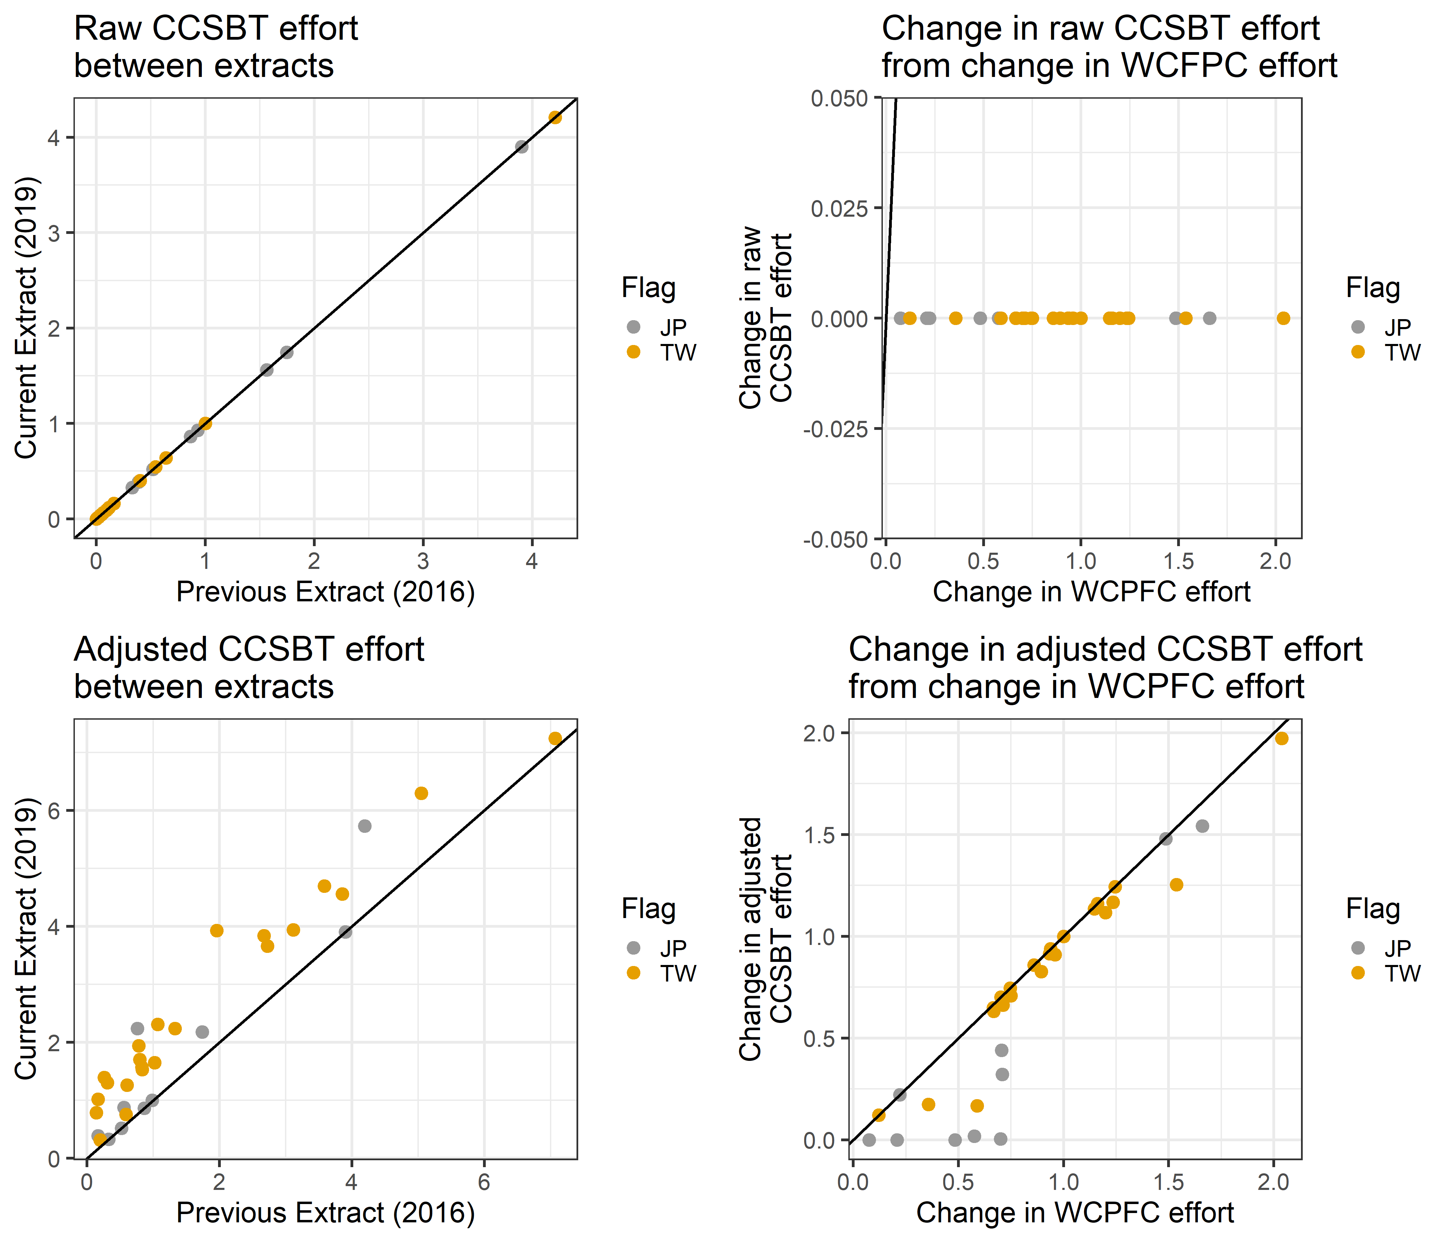
Figure 8. Change in CCSBT effort in relation to change in WCPFC effort (non-core strata). Effort is summed per grid and given in units of million hooks. For non-core strata the raw CCSBT effort is unchanged but the adjusted effort is updated (left column). Changes to the WCPFC effort in non-core strata leads to changes in the adjusted CCSBT effort (right column). A positive change indicates that the effort has increased from the previous extract (2016) to the current extract (2019).

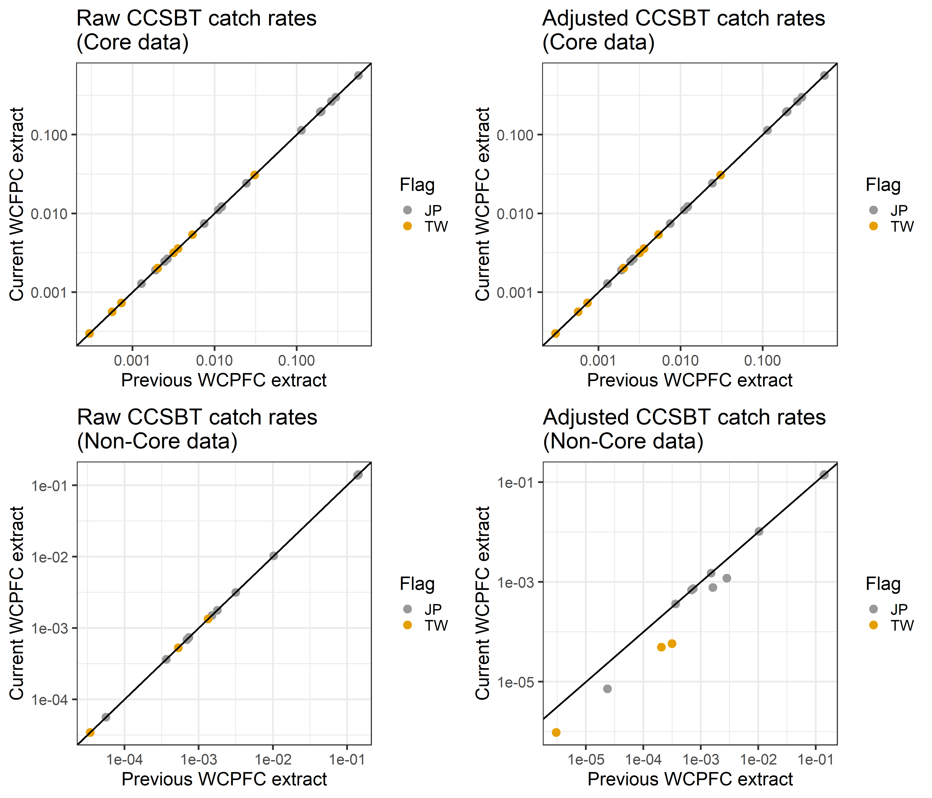
Figure 9. Changes to the raw and adjusted CCSBT catch rates (in average kg per hook per grid for 2007 to 2014) as a result of changes to the WCFPC effort data extract. Only JP and TW are shown, since catch rates from other flags are not adjusted.
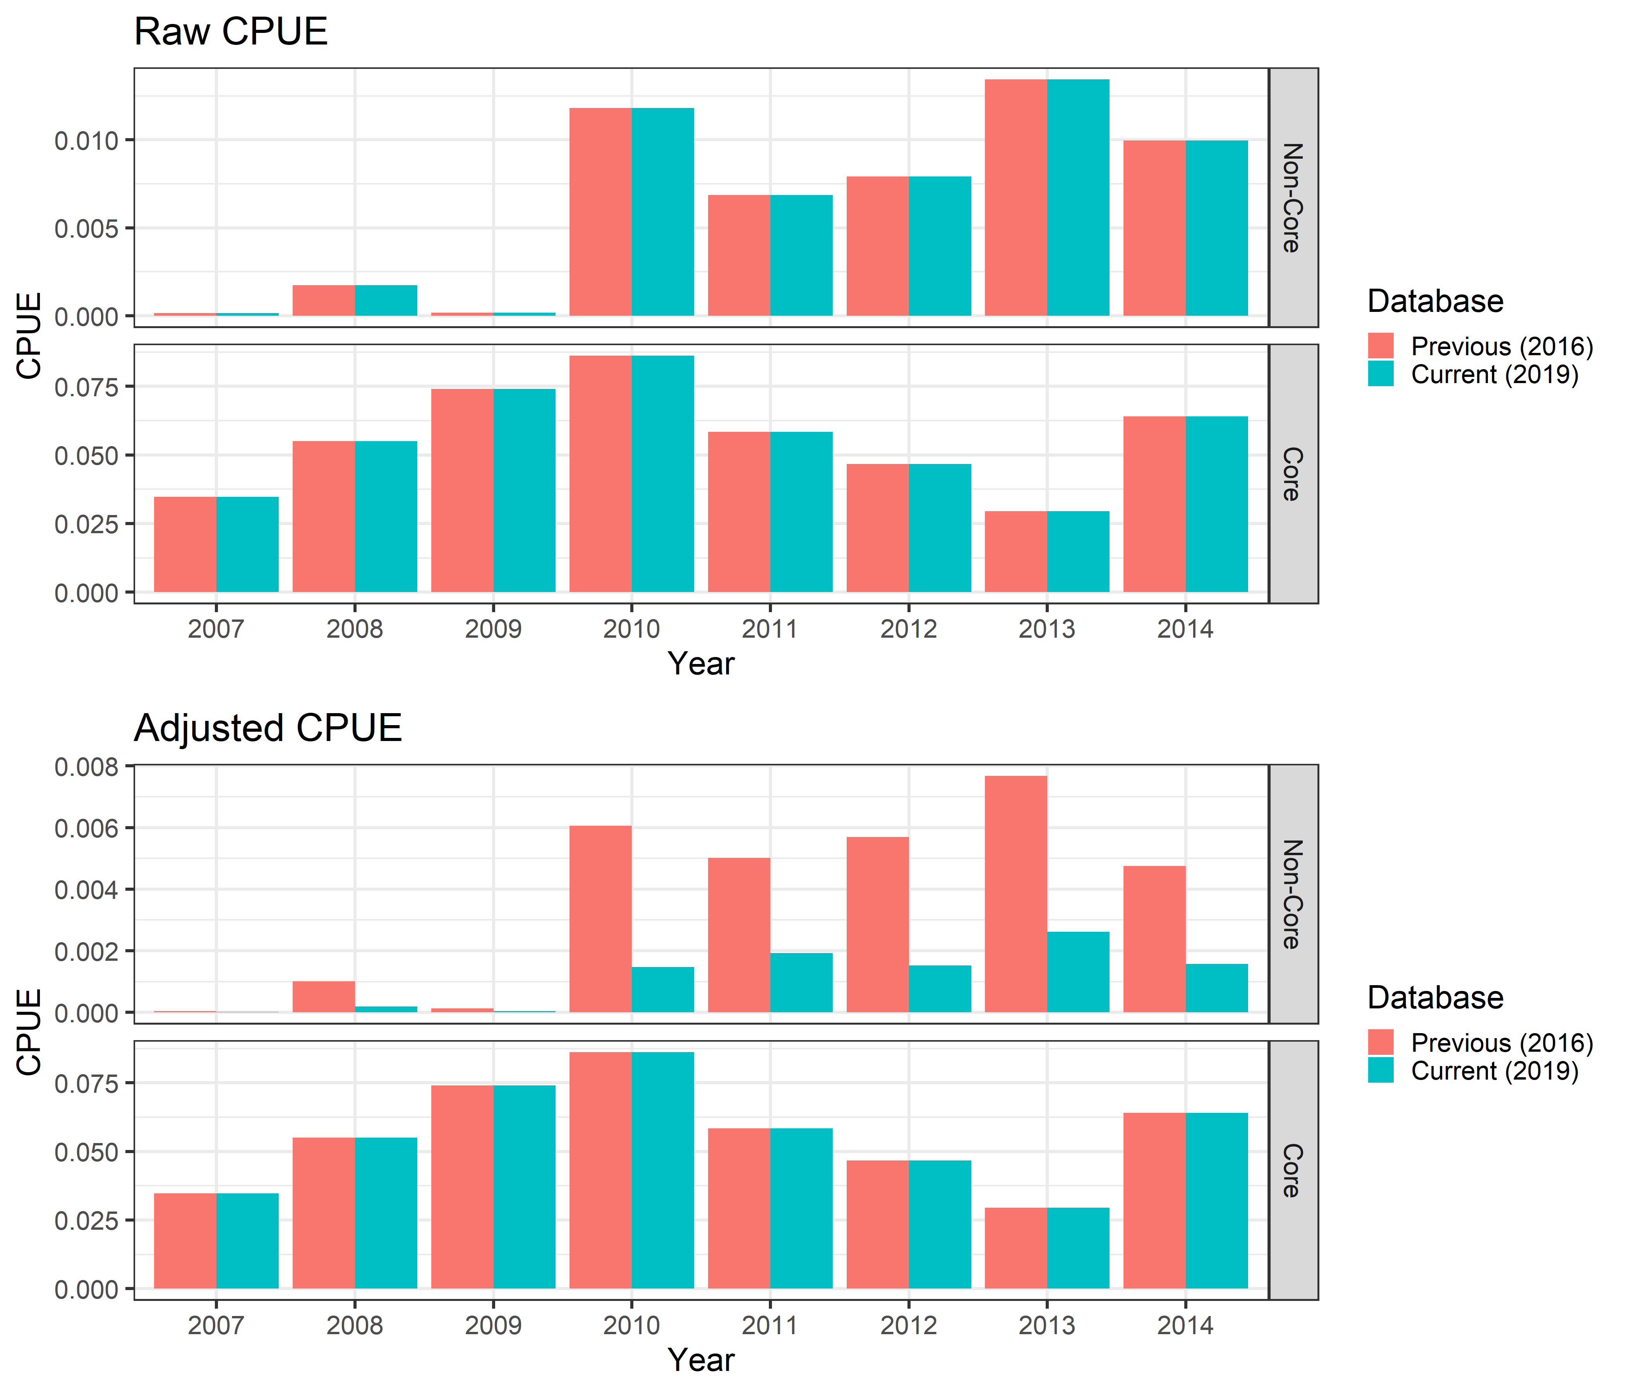
Figure 10. Overall effect of changes to the WCPFC effort data on the average empirical catch rates in kg per hook for JP and TW. The adjusted CPUE for non-core strata has decreased as a result of changes to the WCPFC data extract. The previous (2016) database refers to that used for CCSBT-ESC/1609/BGD02/Rev.1, the current (2019) database refers to that for CCSBT-ESC/1909/33.

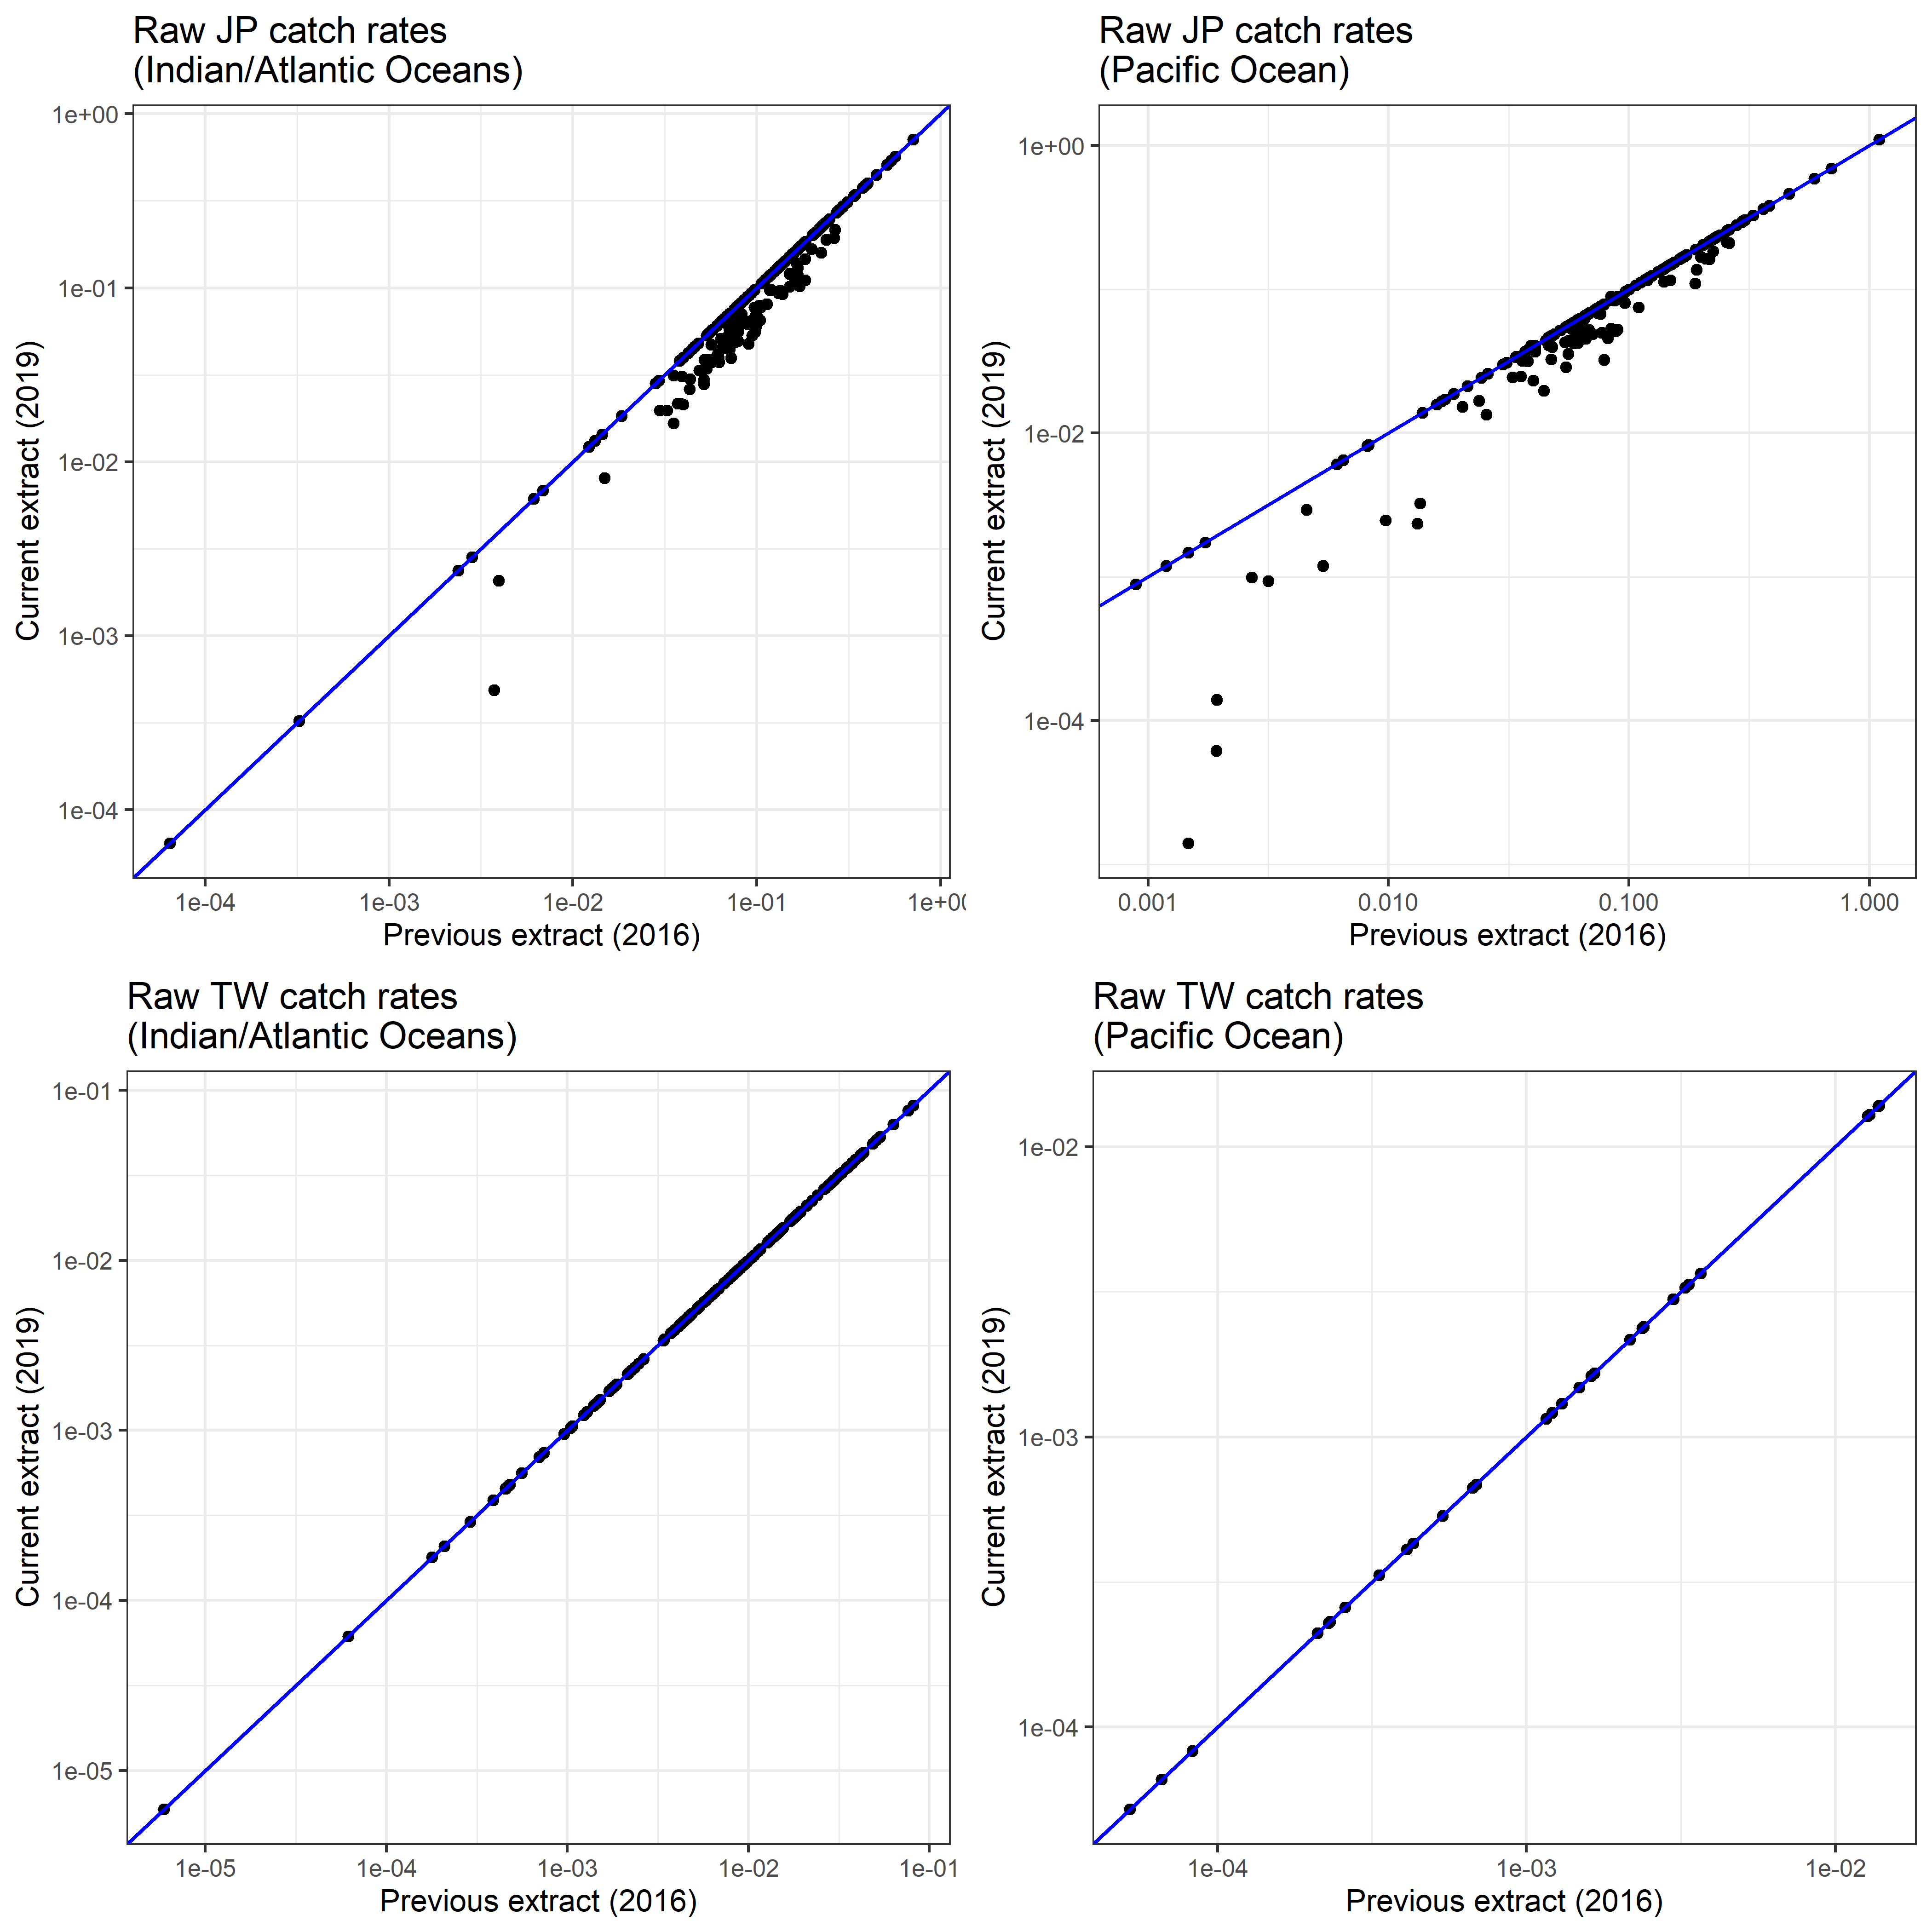
Figure 11. Comparison of the mean catch over effort by quarter for the current (2019) against the previous (2016) analysis. Catch rates are shown on a log₁₀ scale. Revision of the Japanese data extract has led to a decrease in the mean catch rate.

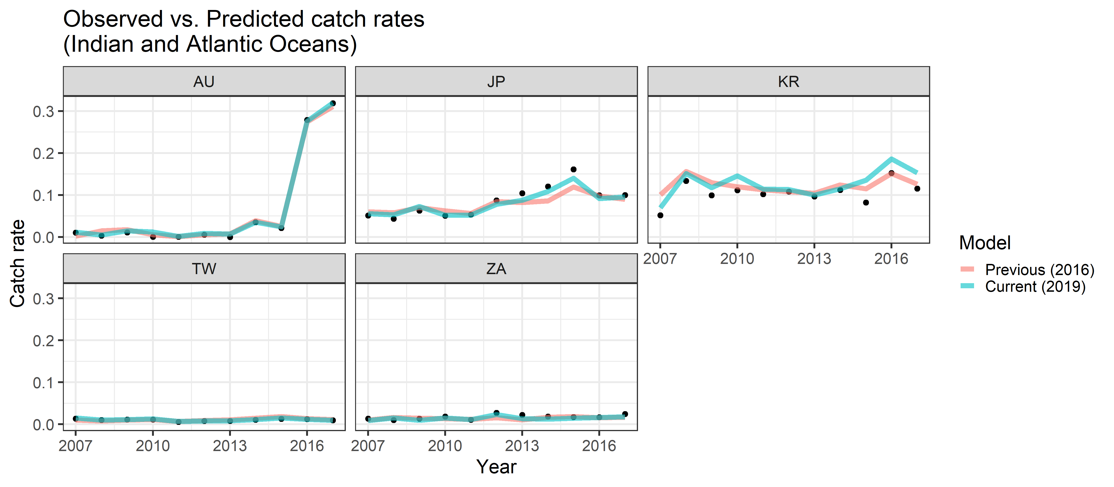

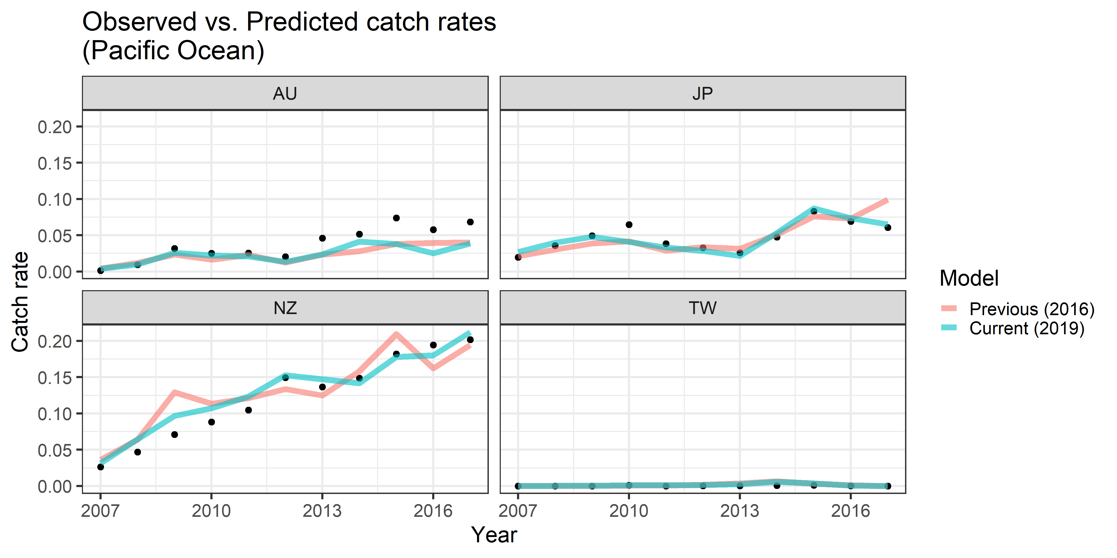

Figure 12. Effect of new model structure on model fit. Note improvements of the model fit to the JP data in recent years, particularly the increase in 2015 and decrease in 2016 and 2017. The previous (2016) model refers to that used for CCSBT-ESC/1609/BGD02/Rev.1, the current (2019) model refers to that for CCSBT-ESC/1909/33.

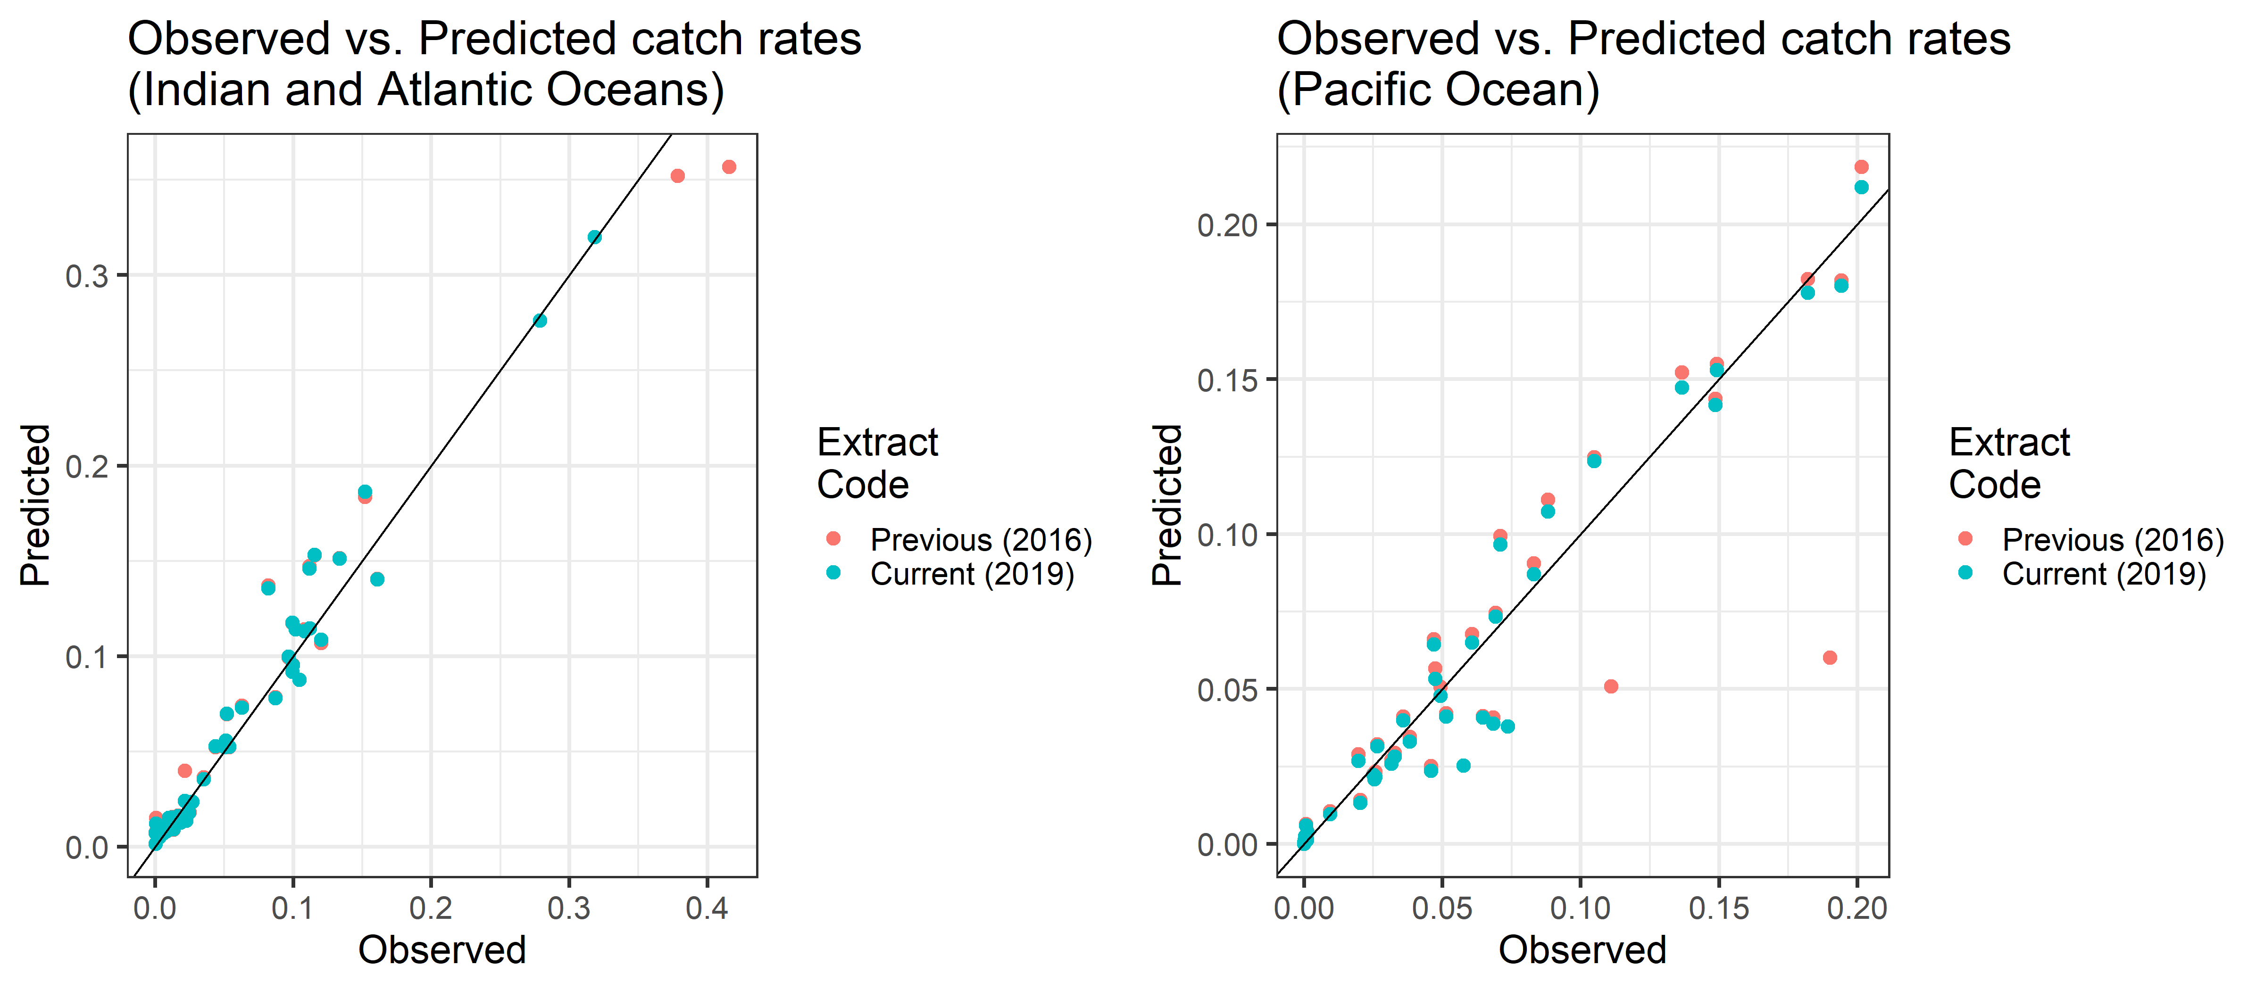
Figure 13. Effect of removing outliers on model fit to the data. Mean observed and predicted values per flag per year are shown. For the Indian/Atlantic poor fits recorded for the previous extract (i.e. with no outliers removed) were from AU in 2016 and 2017. In the Pacific Ocean, poorly fitting observations were from AU in 2015 and 2016.

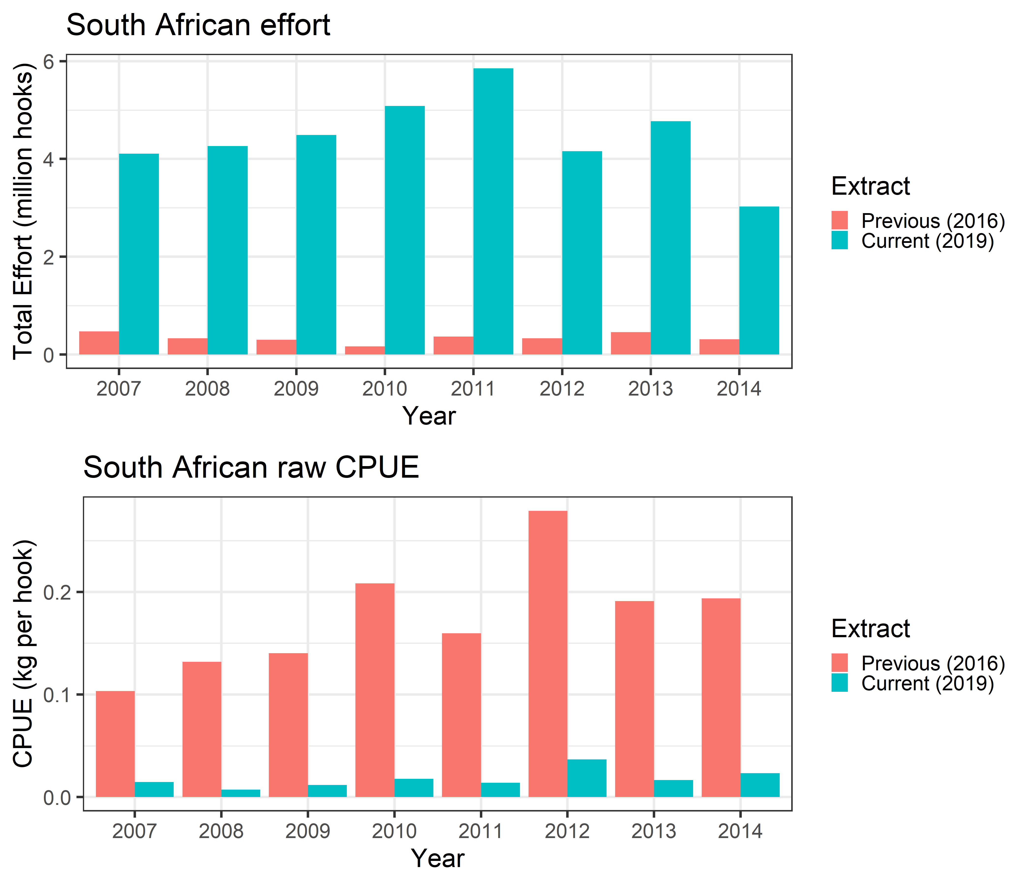
Figure 14. Revised effort and catch rate CCSBT data for South Africa. Comparisons are shown over the year range of the previous 2016 extract (2007 to 2014) presented in CCSBT-ESC/1609/BGD02/Rev.1. Effort reported to the CCSBT has increased, resulting in a reduced raw catch rate for the current (2019) analysis.

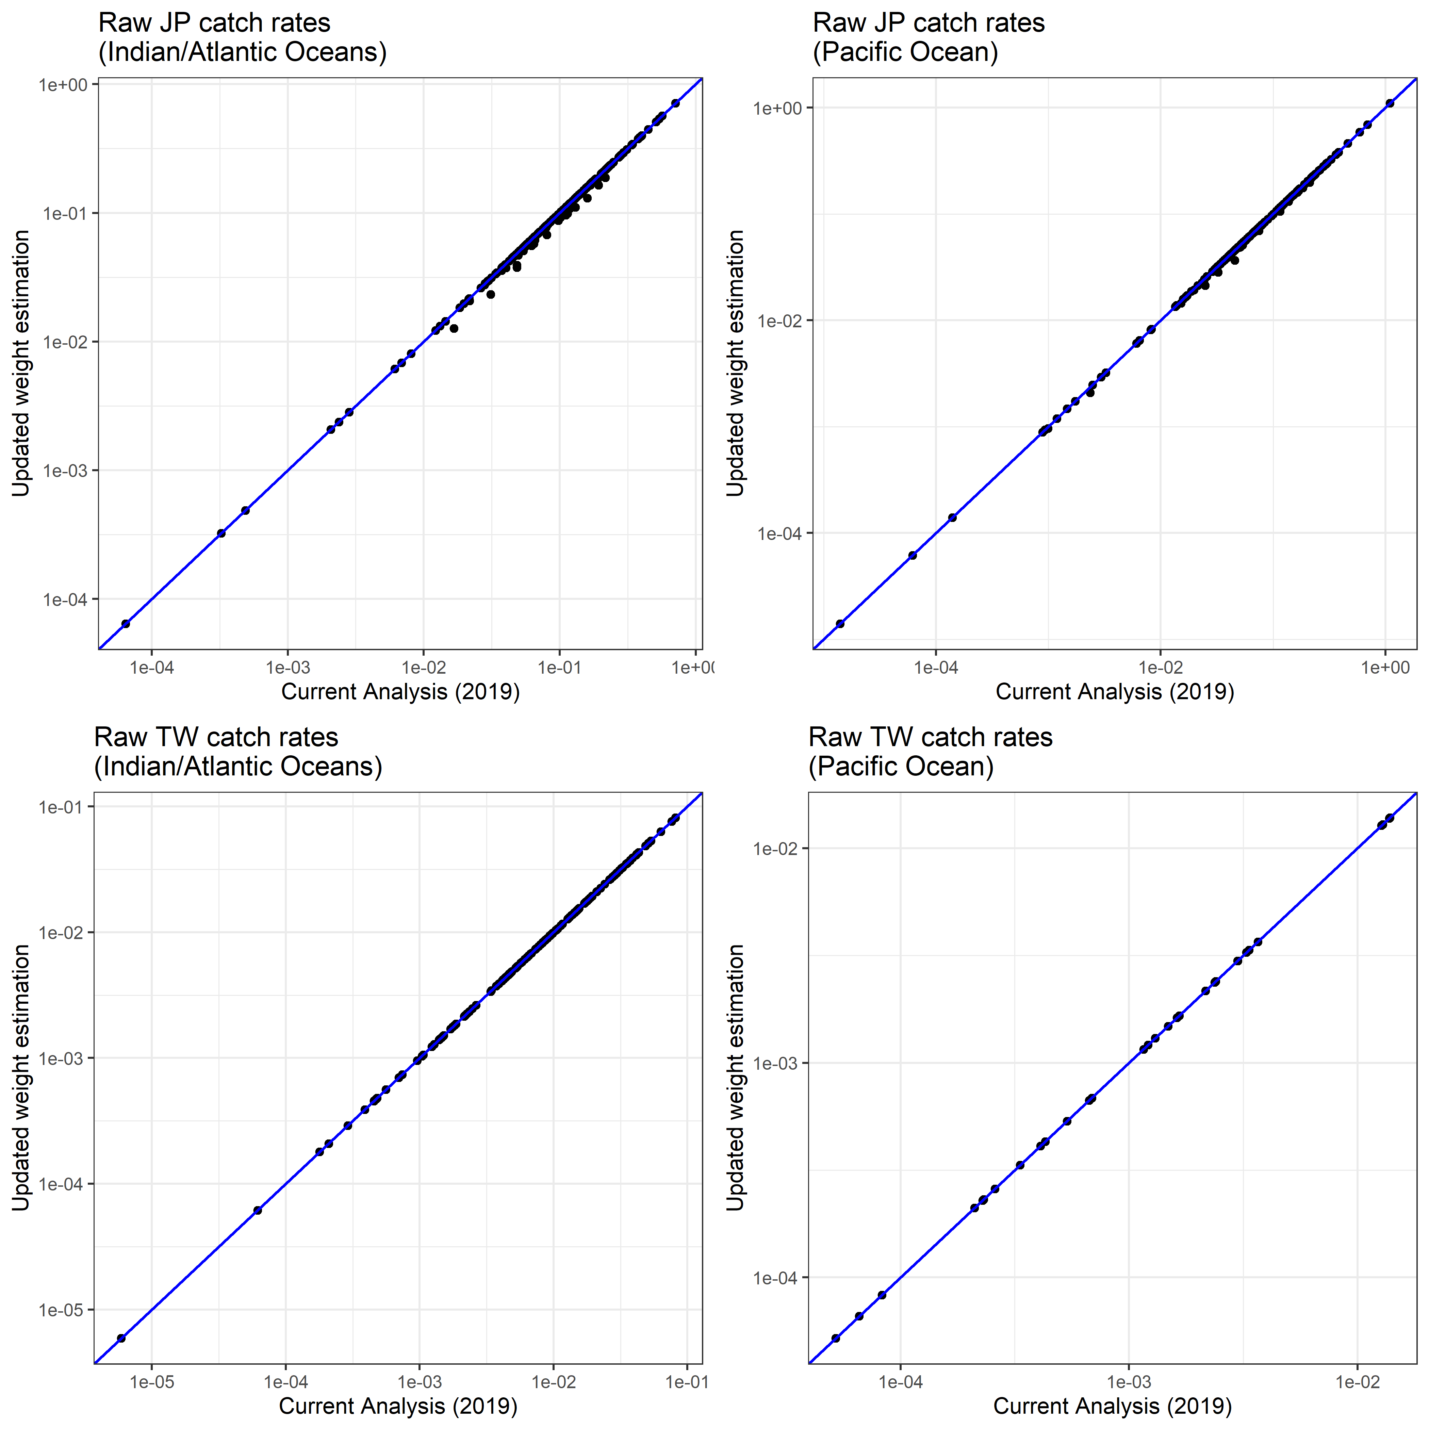
Figure 15. Updated raw catch rates for Japan (JP) and Taiwan (TW) assuming revised individual weight estimation during data preparation (Section 1.2). The revision has led to a slight reduction in the Japanese catch rates in the Indian and Atlantic Oceans, with a less noticeable reduction for the Pacific.

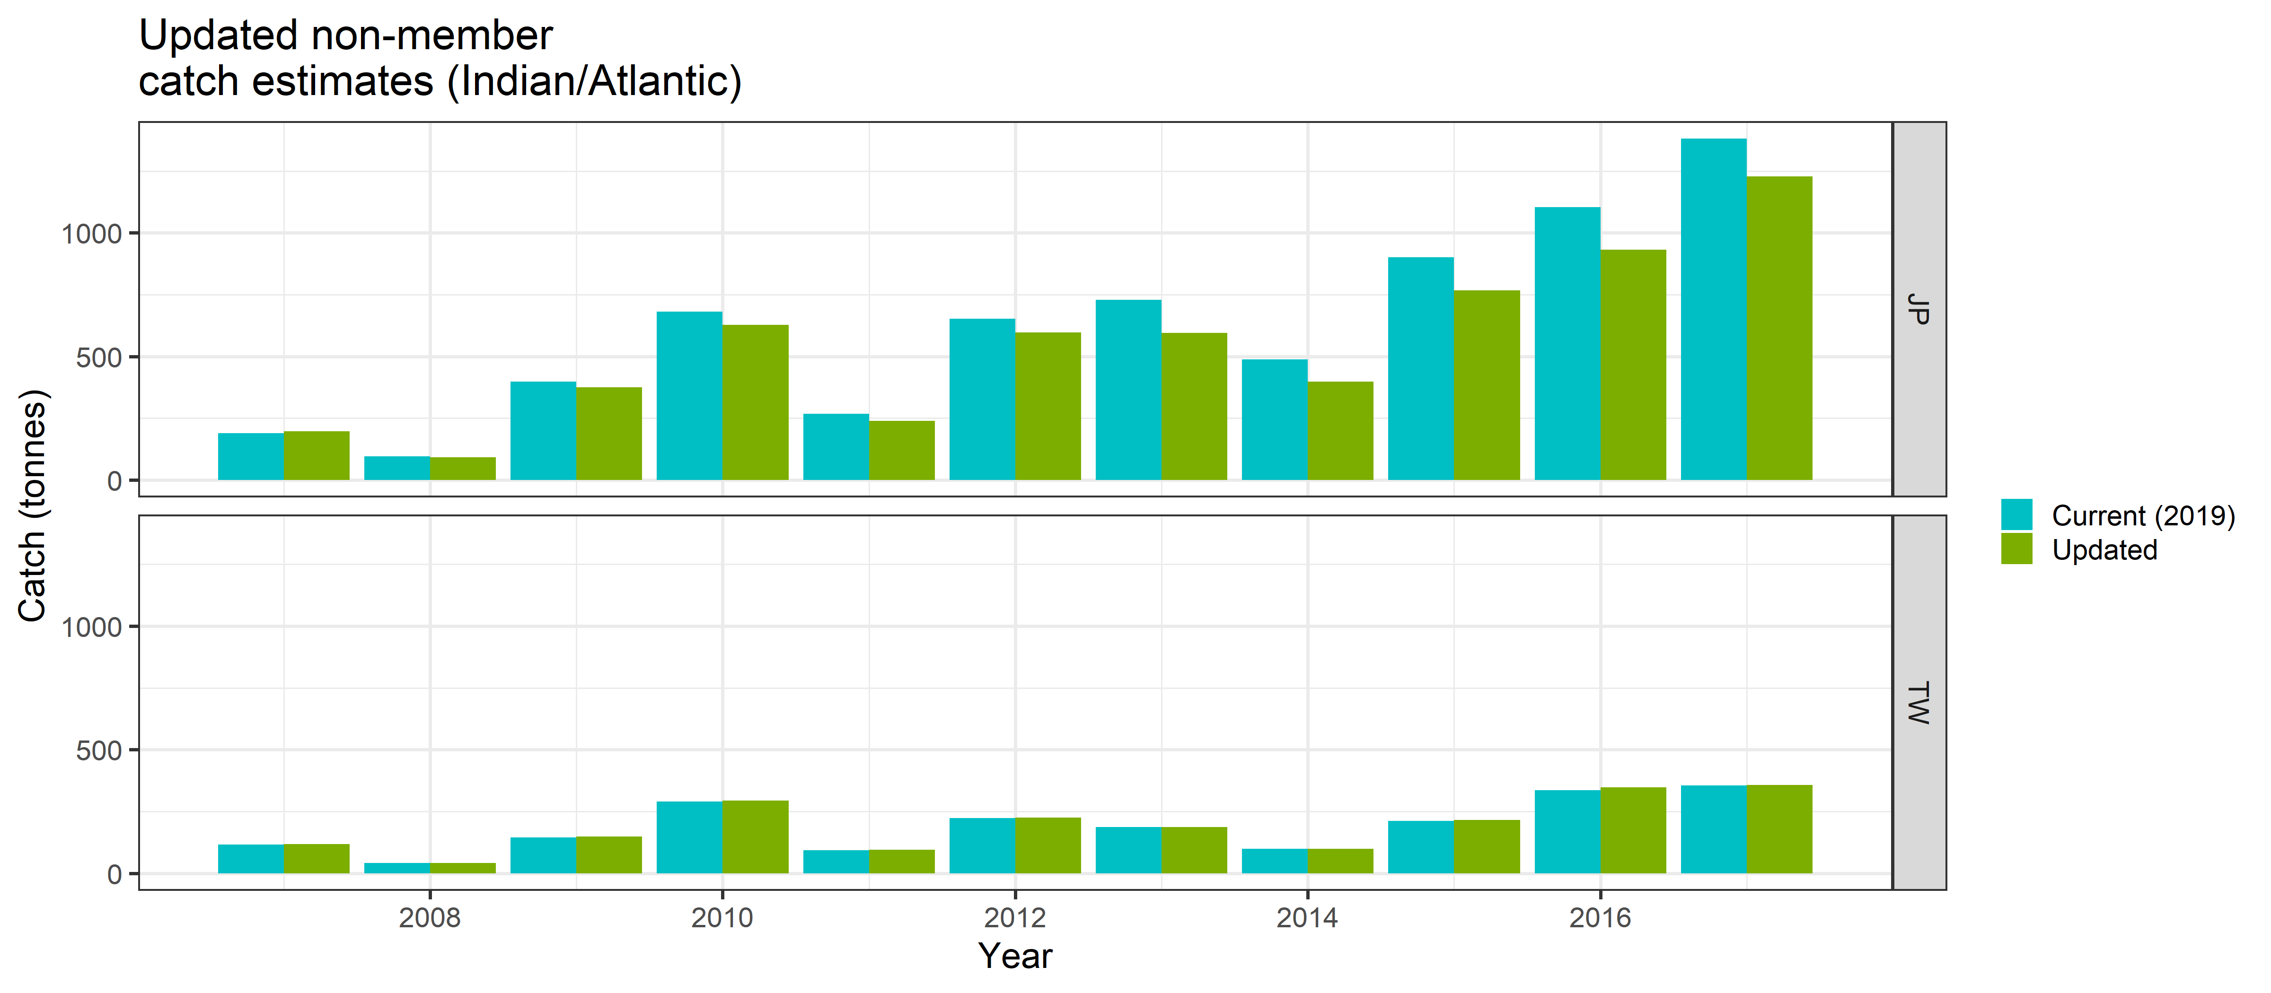
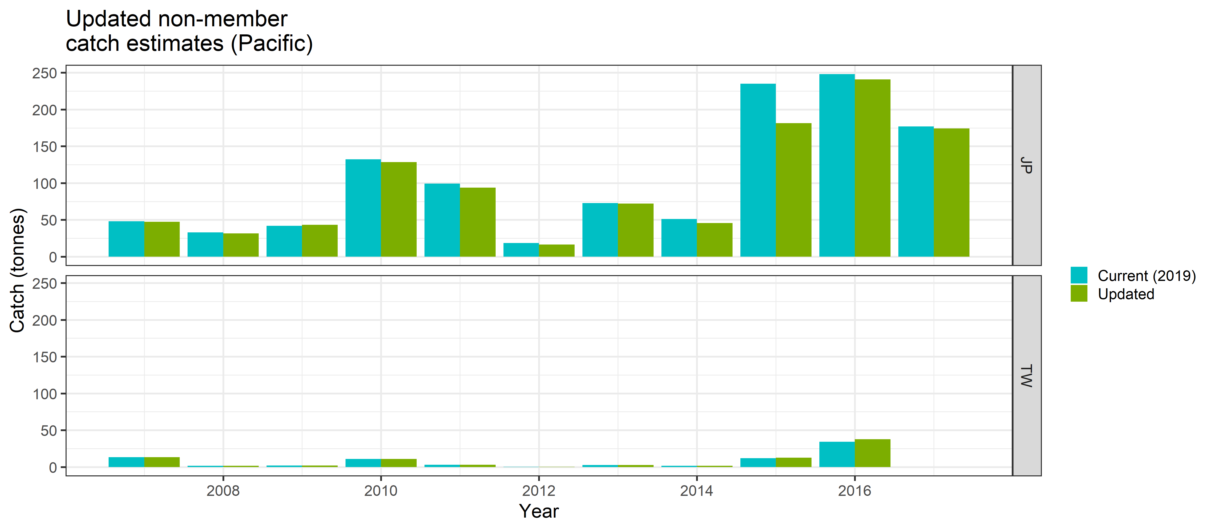
Figure 16. Updated non-member catch estimates (GLM method). Results assuming Japanese (JP) or Taiwanese (TW) catchabilities for non-member fleets are shown. Updated catches refer to those calculated using the new weight-per-fish calculations for Japan (Section 1.2). Current (2019) catches refer to those calculated using the methods presented in CCSBT-ESC/1909/33. Update of the Japanese catch weights has led to a small reduction in the predicted non-member catches when a JP catchability is assumed.

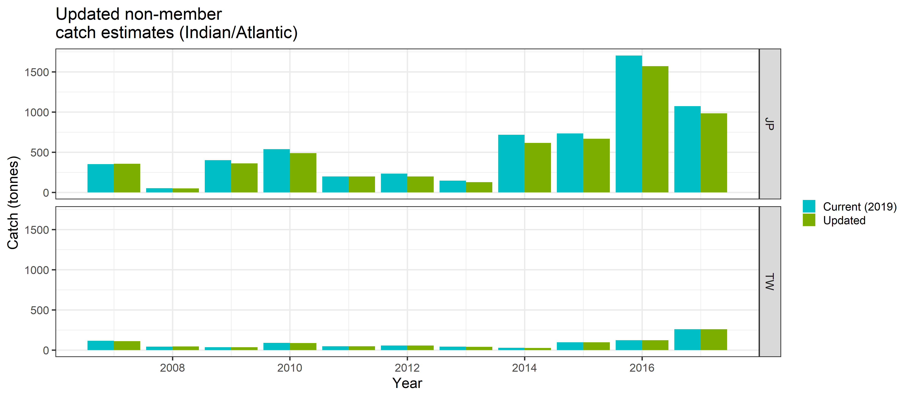

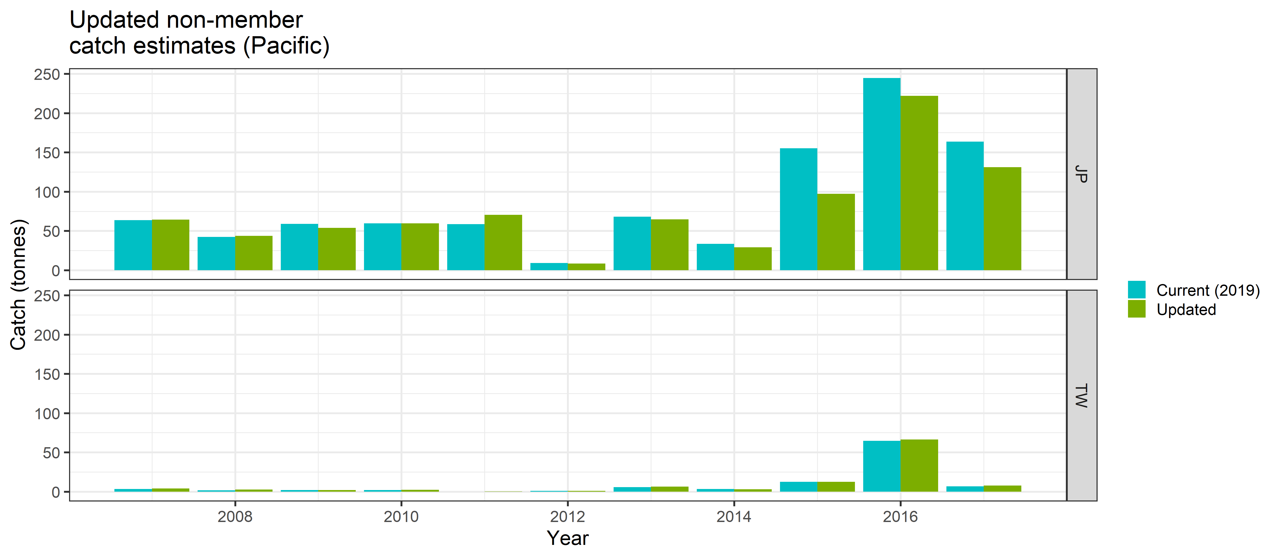
Figure 17. Updated non-member catch estimates (RF method). Results assuming Japanese (JP) or Taiwanese (TW) catchabilities for non-member fleets are shown. Updated catches refer to those calculated using the new weight-per-fish calculations for Japan (Section 1.2). Current (2019) catches refer to those calculated using the methods presented in CCSBT-ESC/1909/33. Update of the Japanese catch weights has led to a small reduction in the predicted non-member catches when a JP catchability is assumed.

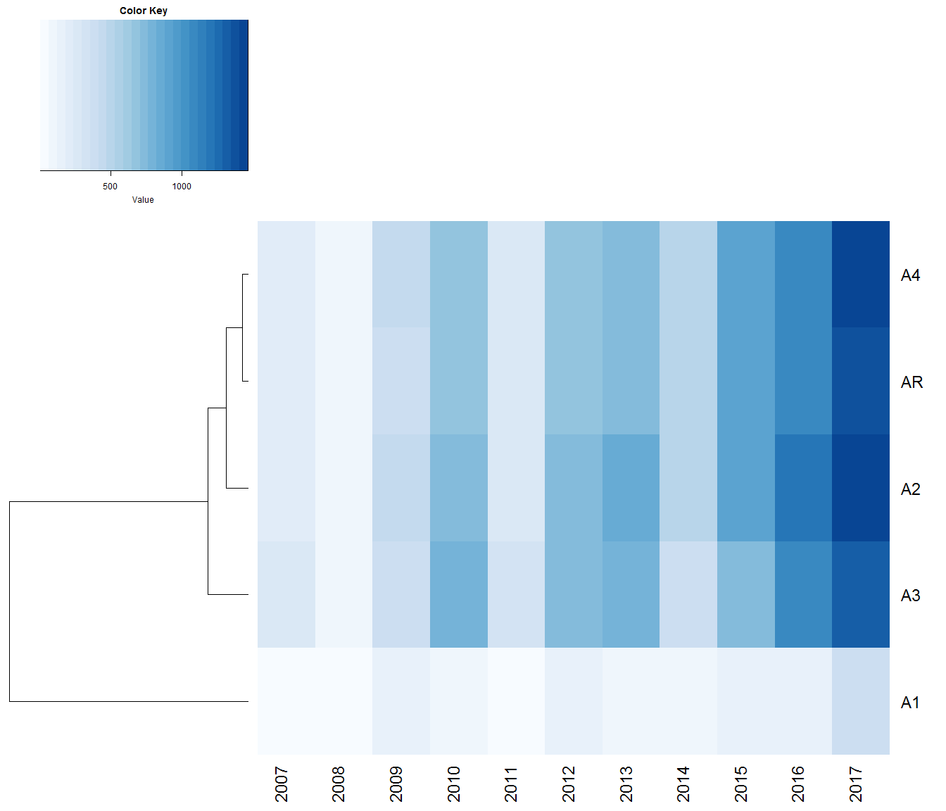

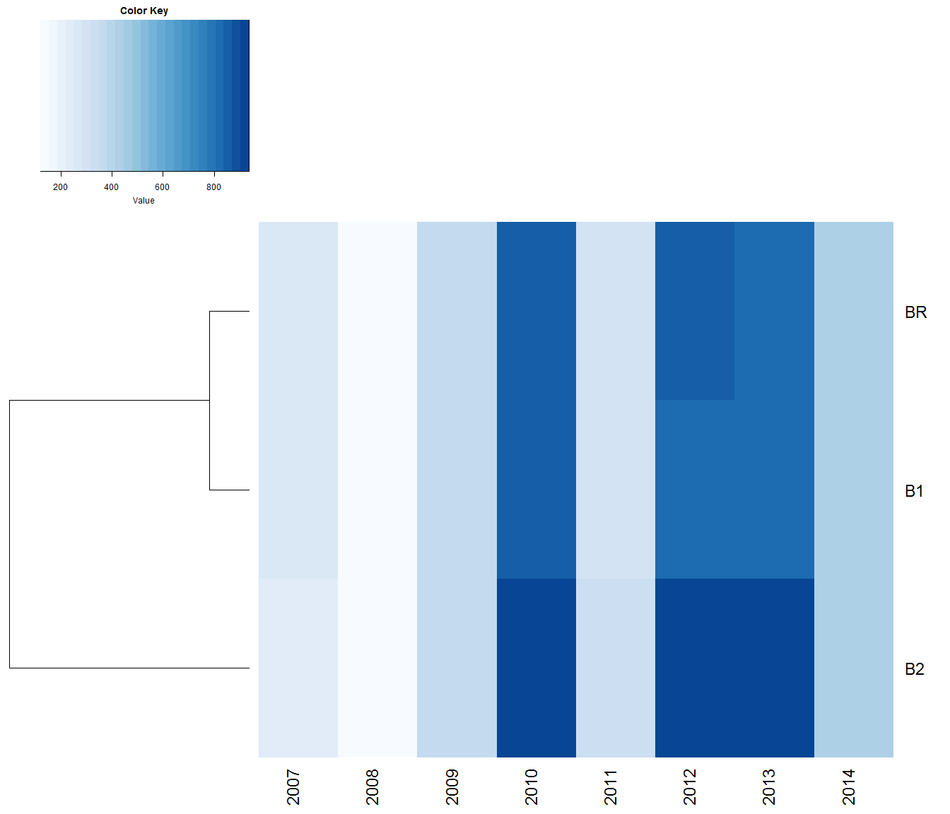
Figure 18. Heat map of catch predictions for the Indian/Atlantic Ocean under alternative model runs: GLM method assuming JP catchability. A hierarchical clustering algorithm is used to group alternative model runs considering Euclidean distance as the metric of similarity. The colour density in each cell represents the predicted catches of each model rounded to the nearest tonne.
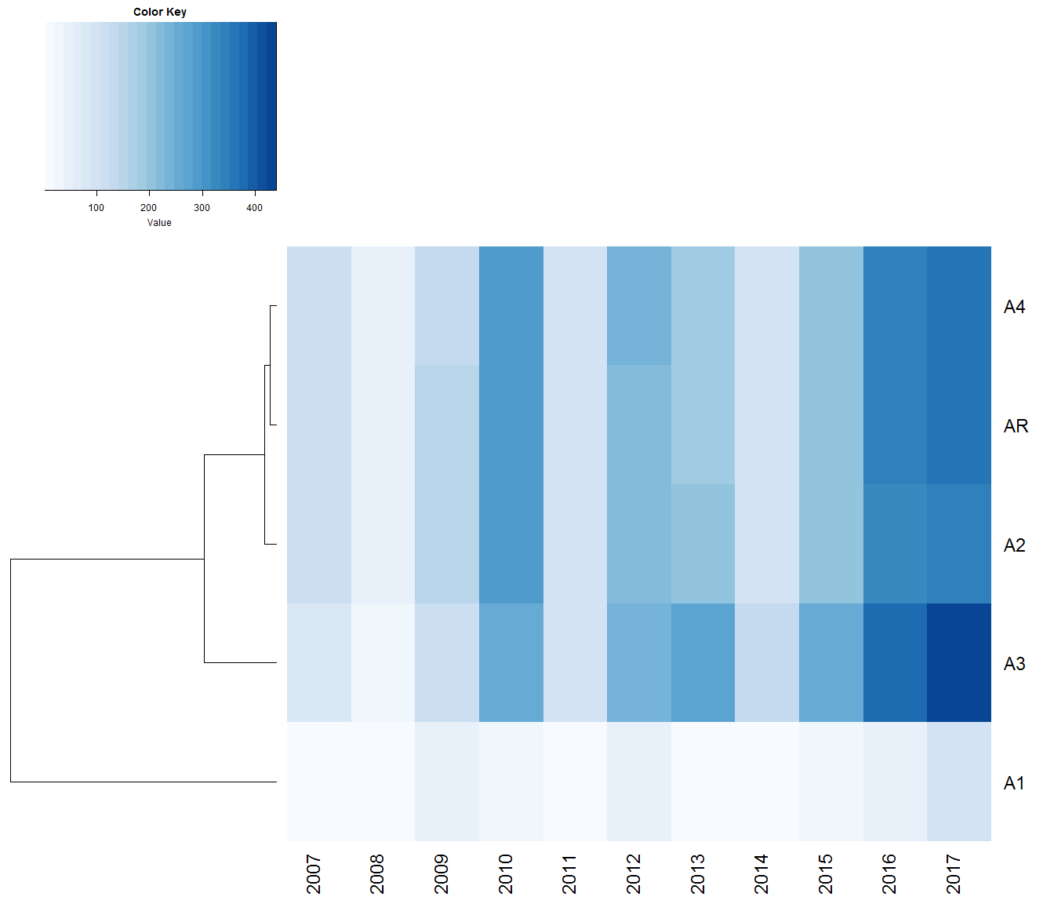

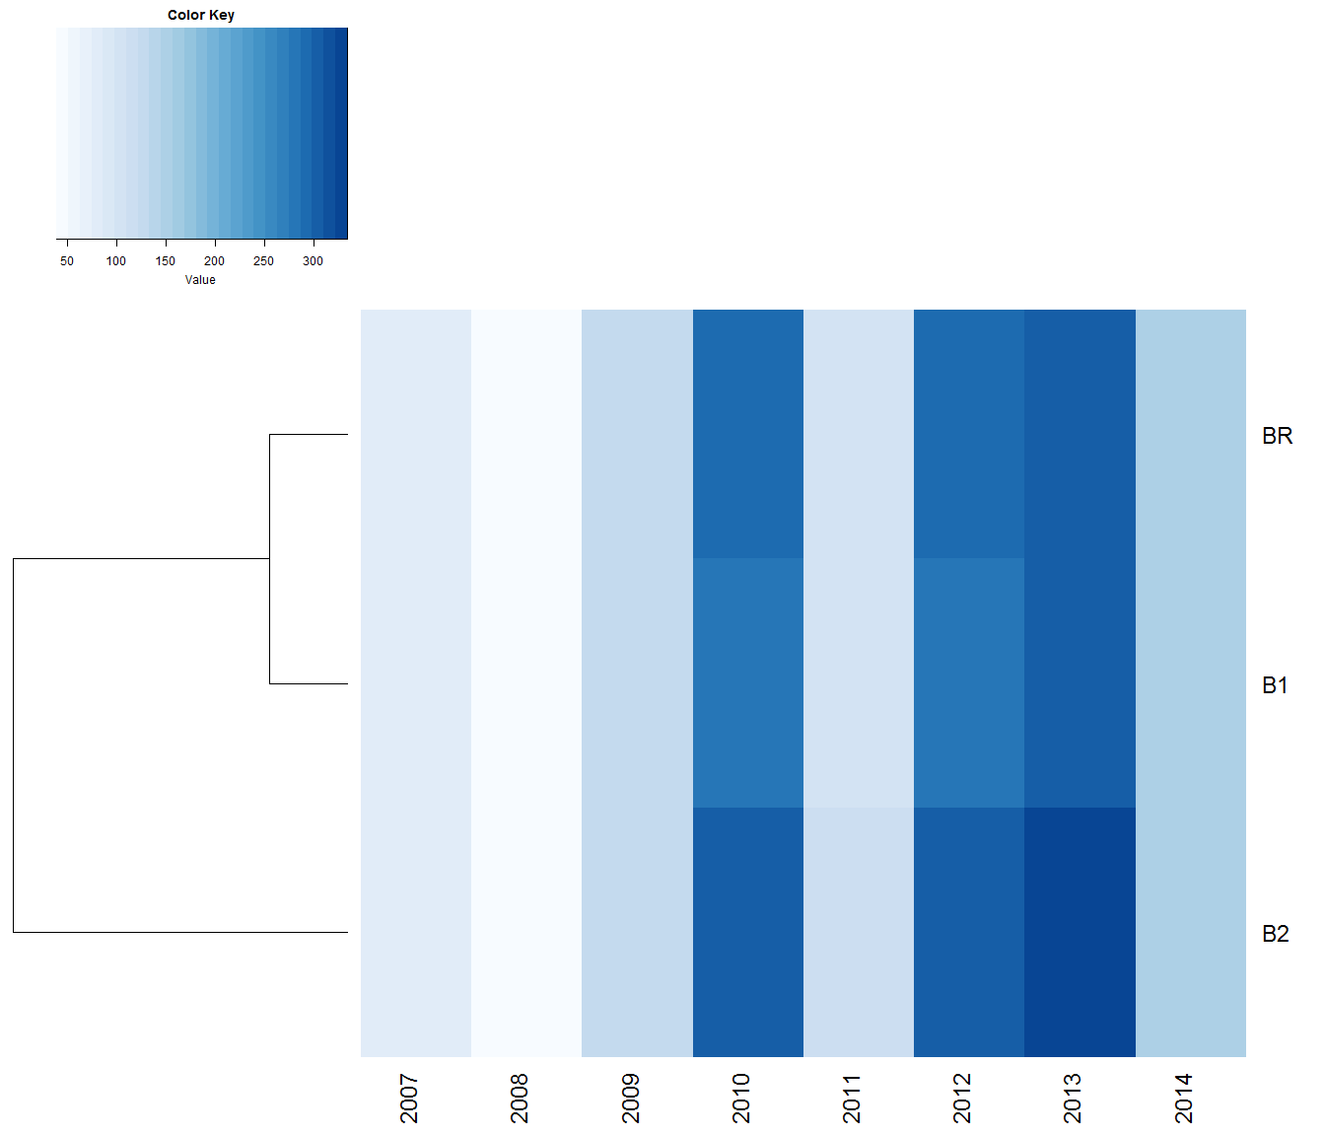
Figure 19. Heat map of catch predictions for the Indian/Atlantic Ocean under alternative model runs: GLM method assuming TW catchability. A hierarchical clustering algorithm is used to group alternative model runs considering Euclidean distance as the metric of similarity. The colour density in each cell represents the predicted catches of each model rounded to the nearest tonne.

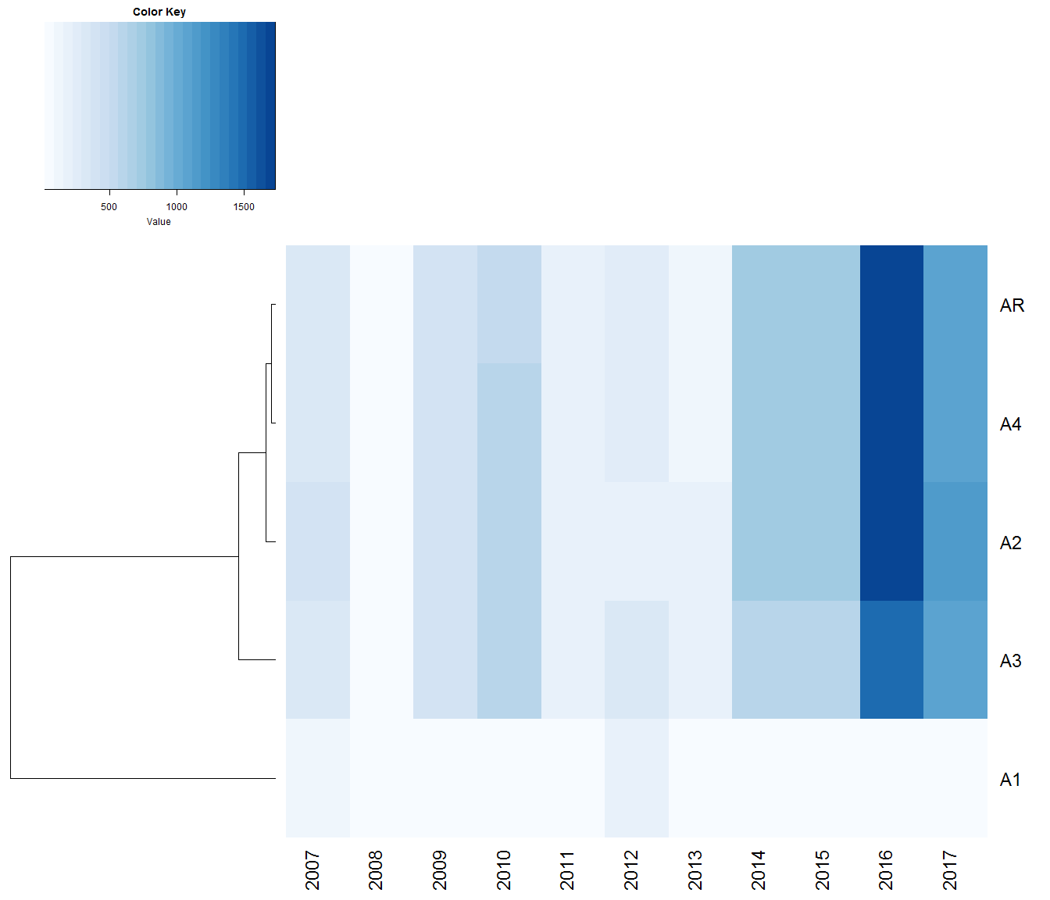

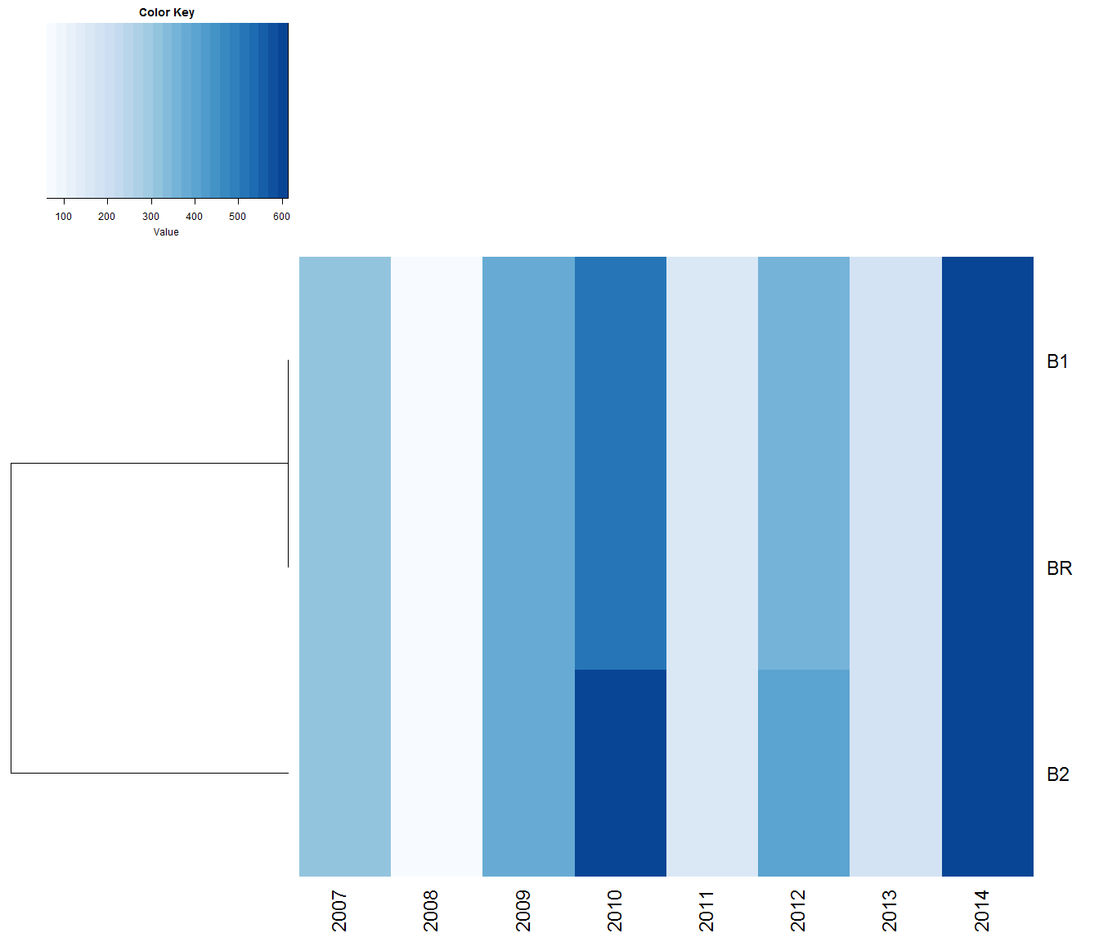
Figure 20. Heat map of catch predictions for the Indian/Atlantic Ocean under alternative model runs: RF method assuming JP catchability. A hierarchical clustering algorithm is used to group alternative model runs considering Euclidean distance as the metric of similarity. The colour density in each cell represents the predicted catches of each model rounded to the nearest tonne.

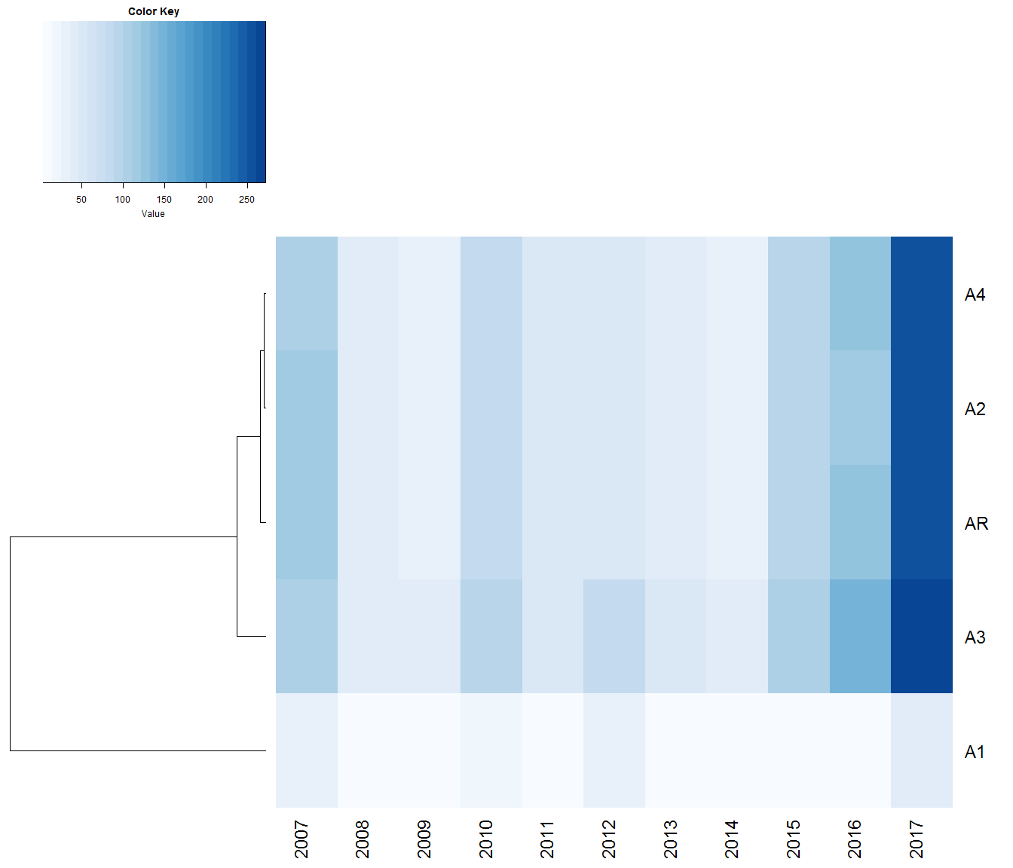

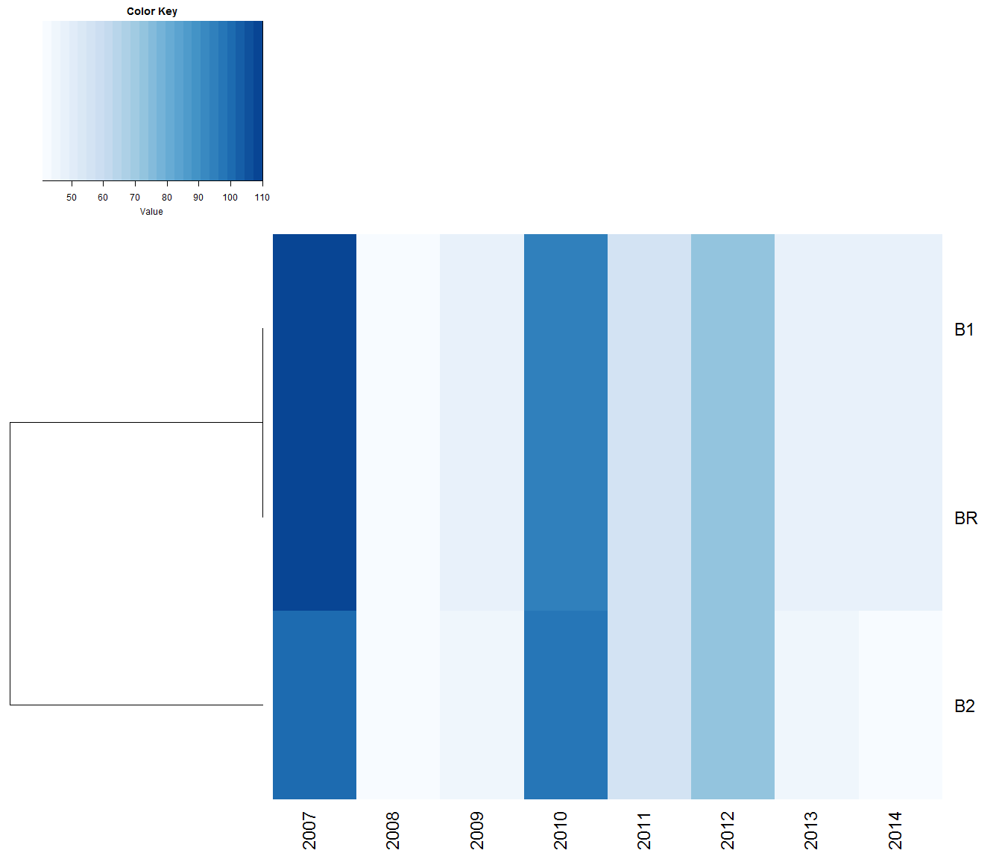
Figure 21. Heat map of catch predictions for the Indian/Atlantic Ocean under alternative model runs: RF method assuming TW catchability. A hierarchical clustering algorithm is used to group alternative model runs considering Euclidean distance as the metric of similarity. The colour density in each cell represents the predicted catches of each model rounded to the nearest tonne.

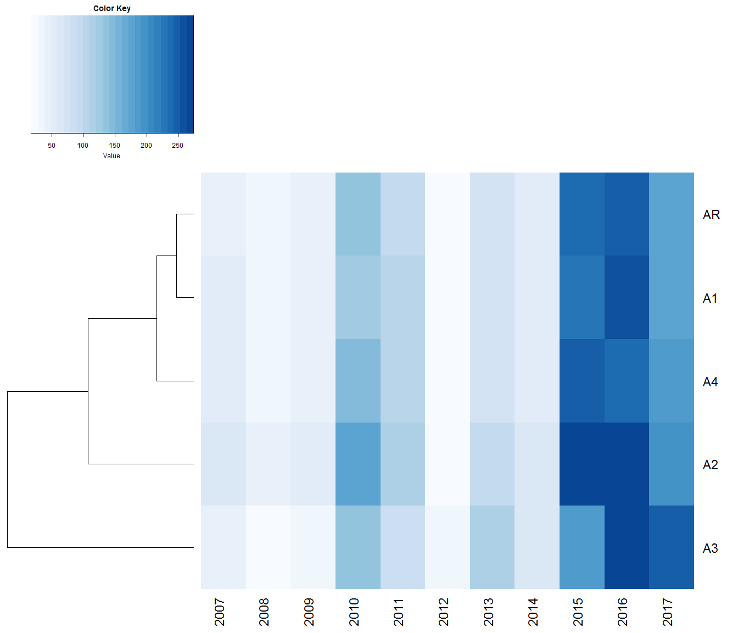

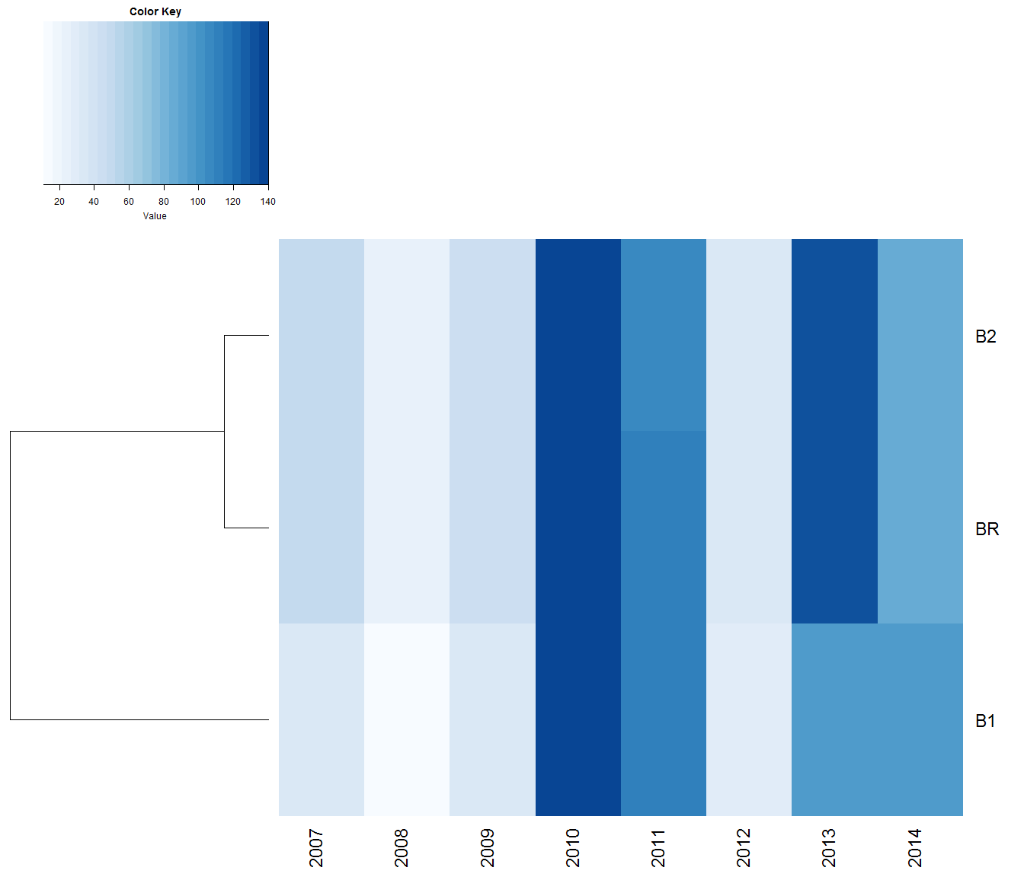
Figure 22. Heat map of catch predictions for the Pacific Ocean under alternative model runs: GLM method assuming JP catchability. A hierarchical clustering algorithm is used to group alternative model runs considering Euclidean distance as the metric of similarity. The colour density in each cell represents the predicted catches of each model rounded to the nearest tonne.

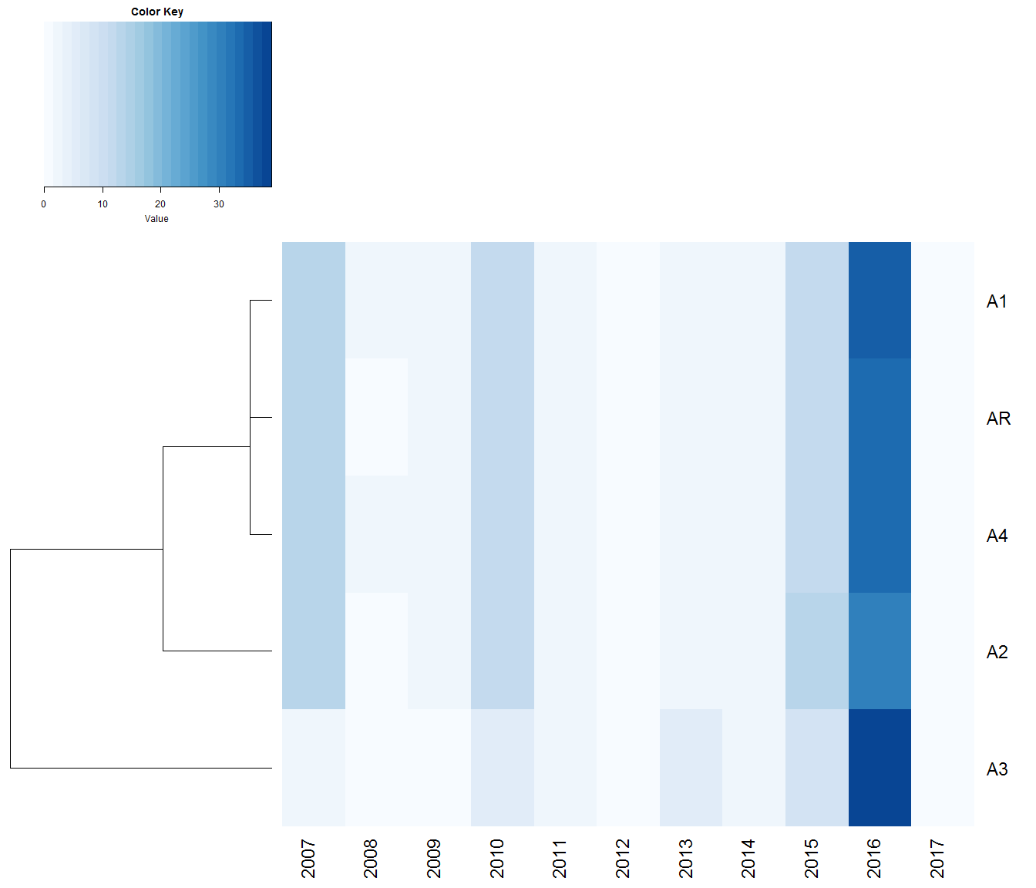

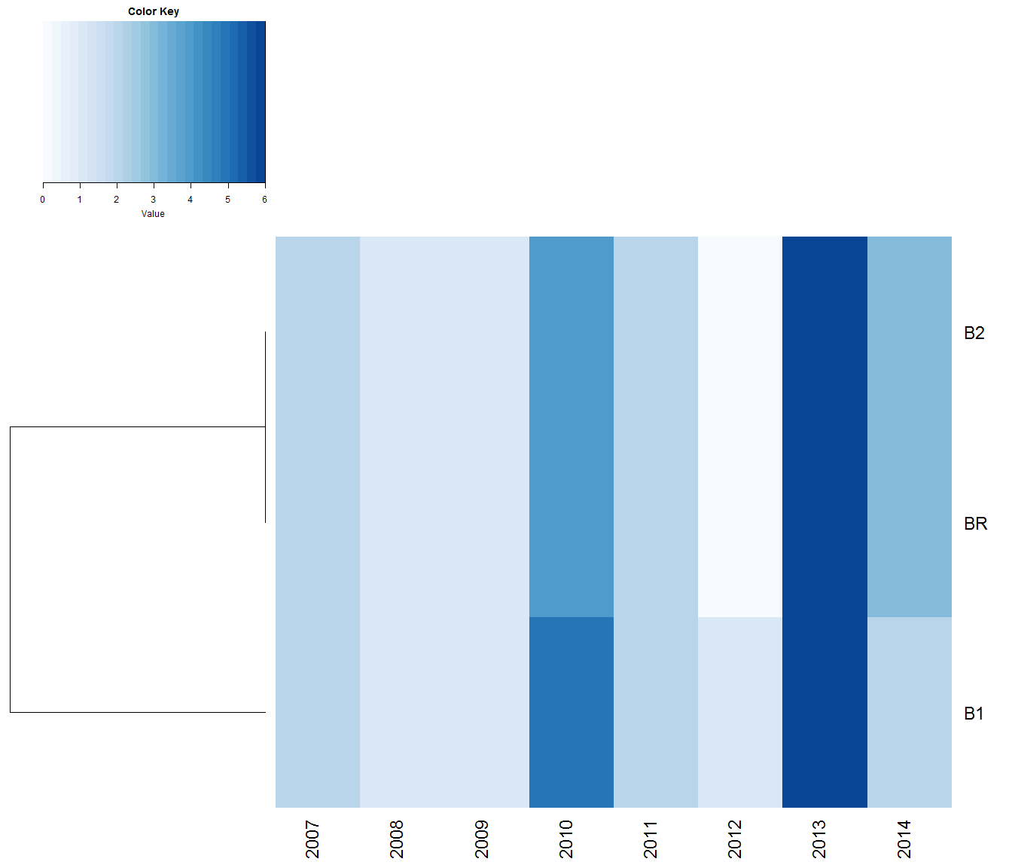
Figure 23. Heat map of catch predictions for the Pacific Ocean under alternative model runs: GLM method assuming TW catchability. A hierarchical clustering algorithm is used to group alternative model runs considering Euclidean distance as the metric of similarity. The colour density in each cell represents the predicted catches of each model rounded to the nearest tonne.

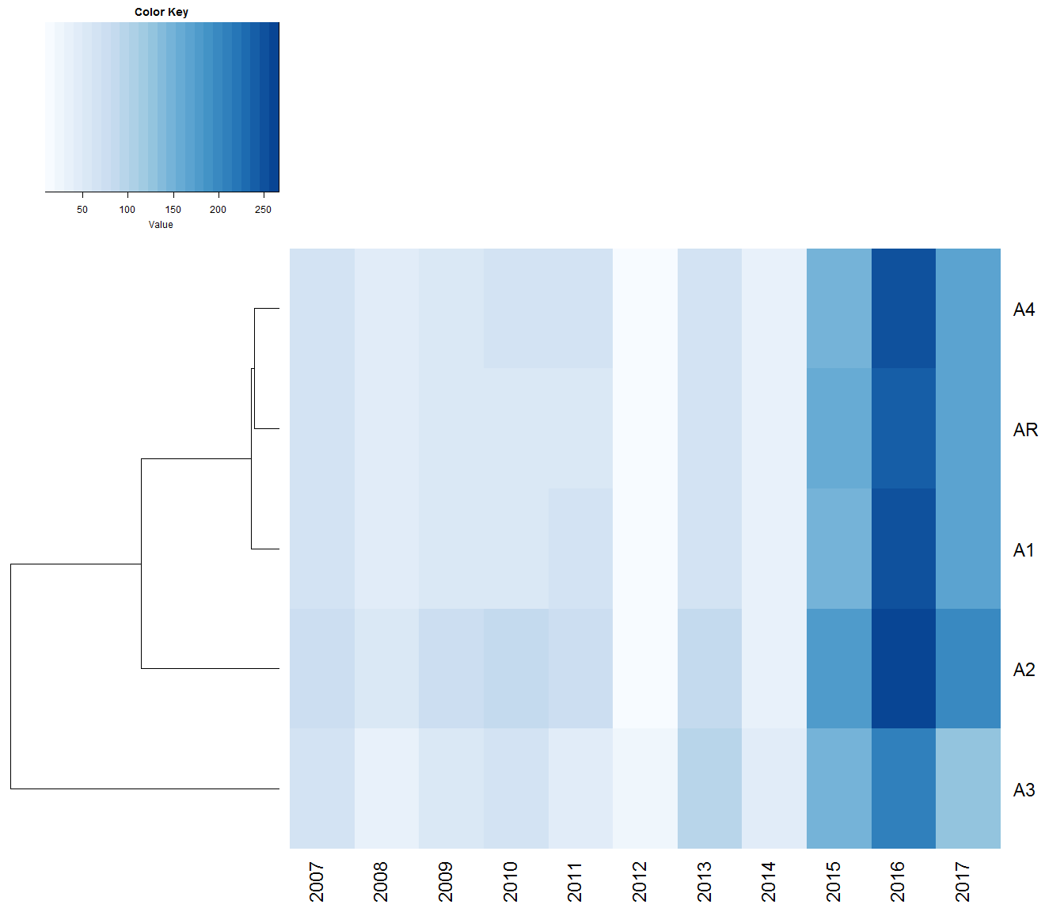
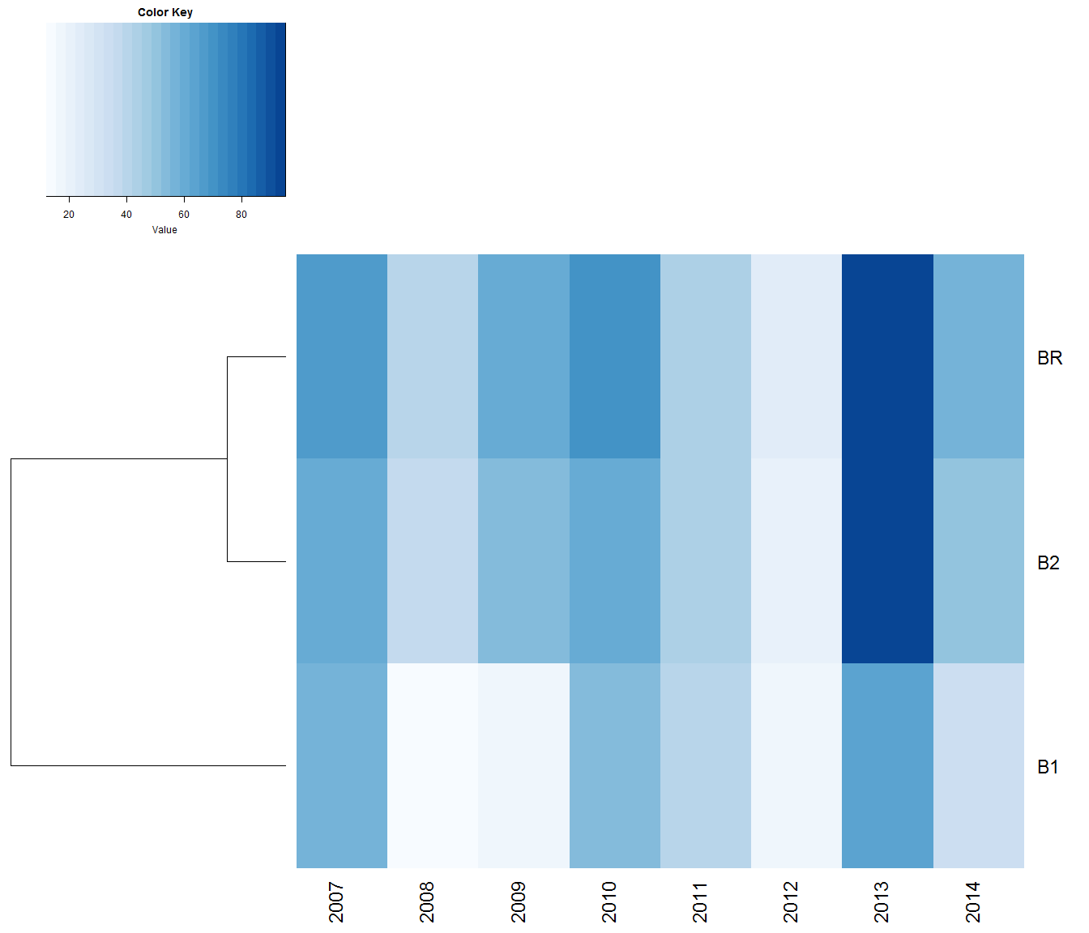
Figure 24. Heat map of catch predictions for the Pacific Ocean under alternative model runs: RF method assuming JP catchability. A hierarchical clustering algorithm is used to group alternative model runs considering Euclidean distance as the metric of similarity. The colour density in each cell represents the predicted catches of each model rounded to the nearest tonne (2016 Study).

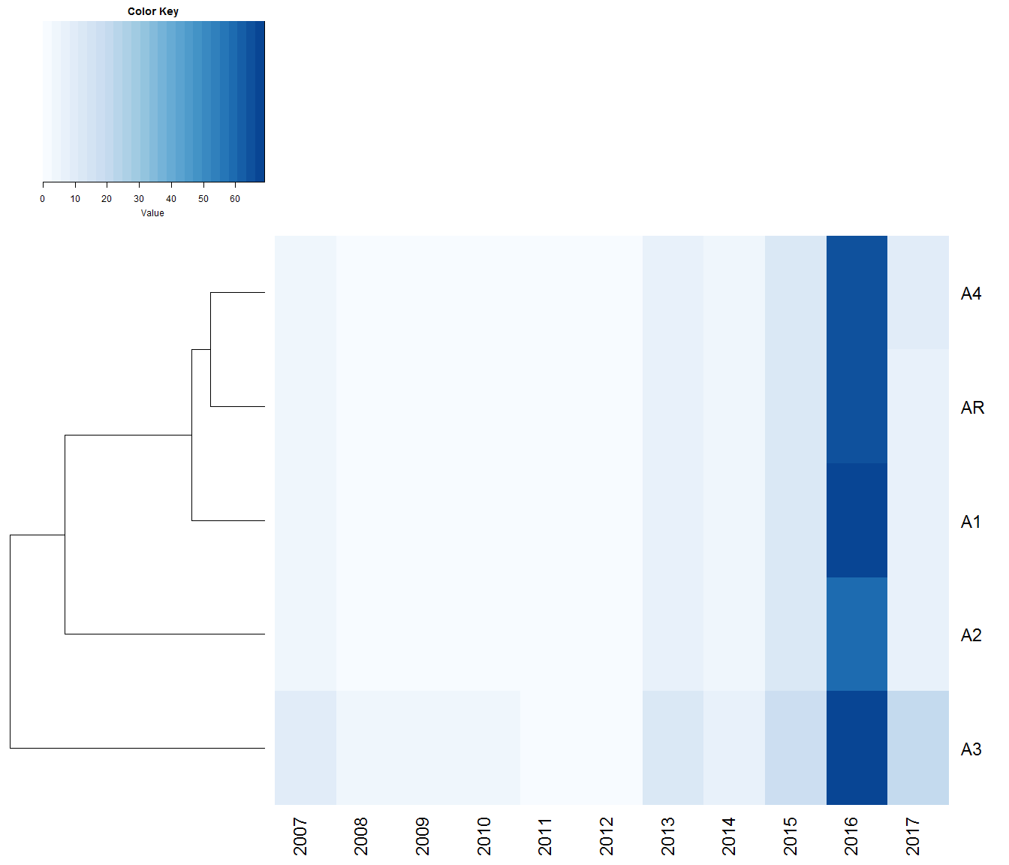

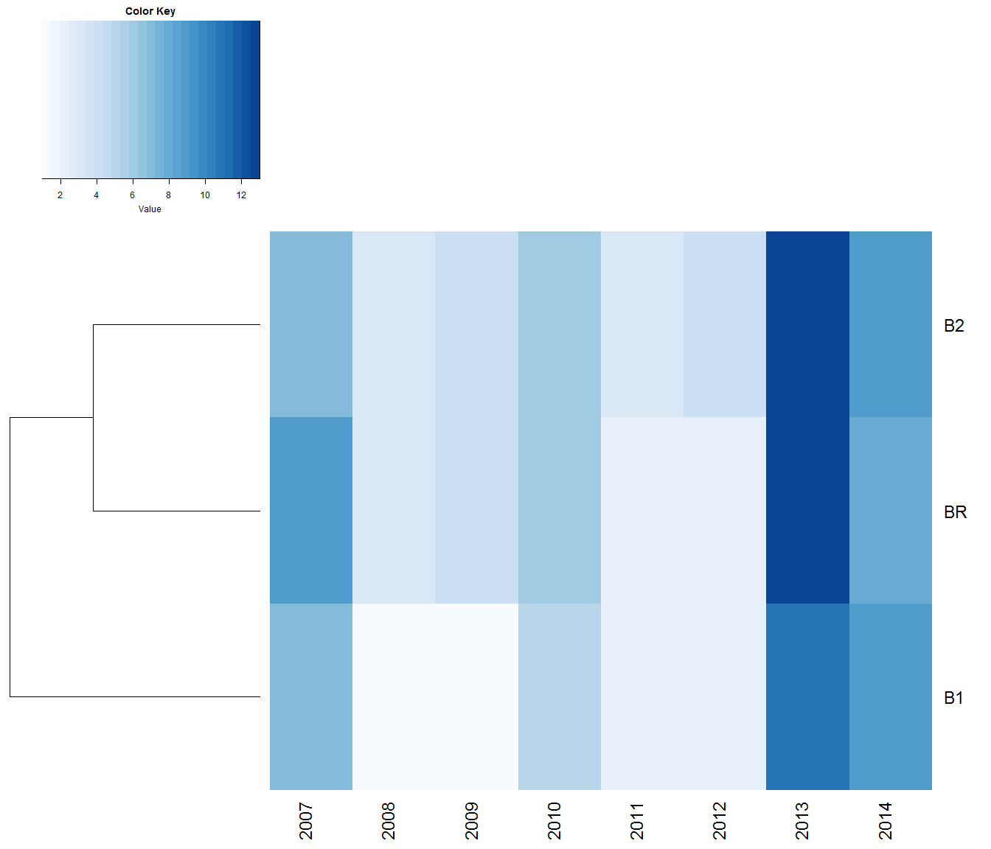

Figure 25. Heat map of catch predictions for the Pacific Ocean under alternative model runs: RF method assuming TW catchability. A hierarchical clustering algorithm is used to group alternative model runs considering Euclidean distance as the metric of similarity. The colour density in each cell represents the predicted catches of each model rounded to the nearest tonne.

Tables

Table 1. Summary table of model runs used to evaluate revisions to the analysis and data between 2016 and 2019. Cells marked as “X” indicate a component that was performed in a manner identical to the 2019 analysis presented in CCSBT-ESC/1909/33. Reference case “A” corresponds to this 2019 analysis. Reference case “B” refers to the same analysis but truncated in 2014 and using the same GLM that was implemented in 2016. This was necessary because the previous iteration of the WCPFC and ZA CCSBT data were only available up until 2014 (model runs B1 and B2).
 | AR | A1 | A2 | A3 | A4 | BR | B1 | B2
Data/Model component | Reference Case A | Revision to the IOTC effort data | Revision to the JP CCSBT catch and effort data | Changes to the GLM covariates | Removal of catch rate outliers from AU and ZA CCSBT data | Reference Case B | Revision to the WCFPC effort data | Revision of ZA CCSBT data
IOTC data | X | 2016 IOTC data | X | X | X | X | X | X
JP CCSBT data | X | X | 2016 JP data | X | X | X | X | X
Model covariates | X | X | X | 2016 GLM | X | 2016 GLM | 2016 GLM | 2016 GLM
Outliers | X | X | X | X | Outliers retained | X | X | X
ZA CCSBT data | X | X | X | X | X | X | X | 2016 ZA data
WCPFC data | X | X | X | X | X | X | 2016 WCPFC data | X
End 2017 | X | X | X | X | X | End 2014 | End 2014 | End 2014

Table 2. Prediction catches for the Indian/Atlantic Oceans under alternative model runs: GLM method assuming JP catchability. Reference case “A” corresponds to the 2019 analysis presented in CCSBT-ESC/1909/33. Reference case “B” refers to the same analysis but truncated in 2014 and using the same GLM that was implemented in 2016. Catches are rounded to the nearest tonne. Average catch across years is shown. The ratio is calculated as the geometric mean of the annual reference case catch relative to the revision: ratios greater than one indicate that the revision led to an increase in the annual catch estimate.

 | Reference Case A | Revision to the IOTC effort data | Revision to the JP CCSBT catch and effort data | Changes to the GLM covariates | Removal of catch rate outliers from AU and ZA CCSBT data | Reference Case B | Revision to the WCFPC effort data | Revision of ZA CCSBT data
 | AR | A1 | A2 | A3 | A4 | BR | B1 | B2
2007 | 190 | 27 | 203 | 243 | 192 | 265 | 263 | 245
2008 | 95 | 6 | 107 | 113 | 93 | 121 | 121 | 135
2009 | 399 | 131 | 444 | 365 | 414 | 365 | 374 | 365
2010 | 680 | 105 | 743 | 781 | 696 | 868 | 850 | 934
2011 | 268 | 40 | 274 | 307 | 256 | 309 | 305 | 330
2012 | 653 | 145 | 734 | 730 | 662 | 839 | 820 | 935
2013 | 730 | 79 | 821 | 788 | 722 | 822 | 819 | 924
2014 | 488 | 84 | 520 | 371 | 492 | 429 | 417 | 433
2015 | 900 | 170 | 904 | 730 | 908
2016 | 1104 | 175 | 1174 | 1080 | 1106
2017 | 1382 | 403 | 1461 | 1291 | 1408
Average | 626 | 124 | 671 | 618 | 632 | 502 | 496 | 538
Ratio | 1.00 | 6.06 | 0.93 | 0.98 | 1.00 | 1.00 | 1.01 | 0.95

Table 3. Predicted catches for the Indian/Atlantic Oceans under alternative model runs: GLM method assuming TW catchability. Reference case “A” corresponds to the 2019 analysis presented in CCSBT-ESC/1909/33. Reference case “B” refers to the same analysis but truncated in 2014 and using the same GLM that was implemented in 2016. Catches are rounded to the nearest tonne. The ratio is calculated as the geometric mean of the annual reference case catch relative to the revision: ratios greater than one indicate that the revision led to an increase in the annual catch estimate.

 | Reference Case A | Revision to the IOTC effort data | Revision to the JP CCSBT catch and effort data | Changes to the GLM covariates | Removal of catch rate outliers from AU and ZA CCSBT data | Reference Case B | Revision to the WCFPC effort data | Revision of ZA CCSBT data
 | AR | A1 | A2 | A3 | A4 | BR | B1 | B2
2007 | 116 | 18 | 114 | 76 | 117 | 86 | 85 | 77
2008 | 42 | 3 | 43 | 37 | 42 | 39 | 39 | 43
2009 | 145 | 55 | 143 | 125 | 139 | 128 | 126 | 124
2010 | 291 | 36 | 288 | 255 | 289 | 289 | 286 | 301
2011 | 93 | 15 | 91 | 104 | 93 | 108 | 109 | 118
2012 | 224 | 38 | 224 | 244 | 233 | 294 | 286 | 307
2013 | 188 | 14 | 197 | 282 | 189 | 300 | 301 | 334
2014 | 98 | 15 | 95 | 129 | 98 | 152 | 152 | 149
2015 | 211 | 35 | 207 | 257 | 209
2016 | 336 | 48 | 322 | 379 | 338
2017 | 355 | 94 | 346 | 439 | 353
Average | 191 | 34 | 188 | 211 | 191 | 175 | 173 | 182
Ratio | 1.00 | 6.57 | 1.01 | 0.95 | 1.00 | 1.00 | 1.01 | 0.97

Table 4. Prediction catches for the Indian/Atlantic Oceans under alternative model runs: RF method assuming JP catchability. Reference case “A” corresponds to the 2019 analysis presented in CCSBT-ESC/1909/33. Reference case “B” refers to the same analysis but truncated in 2014 and using the same GLM that was implemented in 2016. Catches are rounded to the nearest tonne. The ratio is calculated as the geometric mean of the annual reference case catch relative to the revision: ratios greater than one indicate that the revision led to an increase in the annual catch estimate.

 | Reference Case A | Revision to the IOTC effort data | Revision to the JP CCSBT catch and effort data | Changes to the GLM covariates | Removal of catch rate outliers from AU and ZA CCSBT data | Reference Case B | Revision to the WCFPC effort data | Revision of ZA CCSBT data
 | AR | A1 | A2 | A3 | A4 | BR | B1 | B2
2007 | 351 | 131 | 380 | 293 | 335 | 306 | 306 | 313
2008 | 52 | 17 | 64 | 71 | 54 | 61 | 61 | 68
2009 | 401 | 15 | 414 | 377 | 409 | 376 | 376 | 380
2010 | 537 | 71 | 598 | 585 | 565 | 522 | 522 | 593
2011 | 199 | 35 | 213 | 174 | 197 | 168 | 168 | 167
2012 | 233 | 161 | 214 | 340 | 221 | 362 | 362 | 400
2013 | 147 | 28 | 166 | 156 | 148 | 174 | 174 | 173
2014 | 717 | 27 | 711 | 589 | 719 | 613 | 613 | 605
2015 | 732 | 19 | 746 | 630 | 731
2016 | 1704 | 31 | 1728 | 1492 | 1683
2017 | 1073 | 49 | 1121 | 1048 | 1075
Average | 559 | 53 | 578 | 523 | 558 | 323 | 323 | 337
Ratio | 1.00 | 9.89 | 0.95 | 1.00 | 1.00 | 1.00 | 1.00 | 0.96

Table 5. Prediction catches for the Indian/Atlantic Oceans under alternative model runs: RF method assuming TW catchability. Reference case “A” corresponds to the 2019 analysis presented in CCSBT-ESC/1909/33. Reference case “B” refers to the same analysis but truncated in 2014 and using the same GLM that was implemented in 2016. Catches are rounded to the nearest tonne. The ratio is calculated as the geometric mean of the annual reference case catch relative to the revision: ratios greater than one indicate that the revision led to an increase in the annual catch estimate.

 | Reference Case A | Revision to the IOTC effort data | Revision to the JP CCSBT catch and effort data | Changes to the GLM covariates | Removal of catch rate outliers from AU and ZA CCSBT data | Reference Case B | Revision to the WCFPC effort data | Revision of ZA CCSBT data
 | AR | A1 | A2 | A3 | A4 | BR | B1 | B2
2007 | 115 | 28 | 111 | 107 | 110 | 110 | 110 | 100
2008 | 42 | 7 | 42 | 42 | 43 | 43 | 43 | 42
2009 | 36 | 5 | 35 | 46 | 36 | 47 | 47 | 45
2010 | 88 | 23 | 86 | 99 | 86 | 96 | 96 | 97
2011 | 47 | 10 | 47 | 57 | 47 | 57 | 57 | 56
2012 | 56 | 27 | 55 | 81 | 56 | 72 | 72 | 73
2013 | 41 | 8 | 40 | 51 | 40 | 49 | 49 | 45
2014 | 28 | 4 | 28 | 38 | 28 | 47 | 47 | 41
2015 | 95 | 4 | 98 | 109 | 96
2016 | 122 | 6 | 121 | 147 | 123
2017 | 259 | 39 | 257 | 271 | 255
Average | 84 | 15 | 84 | 95 | 84 | 65 | 65 | 62
Ratio | 1.00 | 6.42 | 1.01 | 0.85 | 1.01 | 1.00 | 1.00 | 1.05

Table 6. Prediction catches for the Pacific Ocean under alternative model runs: GLM method assuming JP catchability. Reference case “A” corresponds to the 2019 analysis presented in CCSBT-ESC/1909/33. Reference case “B” refers to the same analysis but truncated in 2014 and using the same GLM that was implemented in 2016. Catches are rounded to the nearest tonne. The ratio is calculated as the geometric mean of the annual reference case catch relative to the revision: ratios greater than one indicate that the revision led to an increase in the annual catch estimate.

 | Reference Case A | Revision to the IOTC effort data | Revision to the JP CCSBT catch and effort data | Changes to the GLM covariates | Removal of catch rate outliers from AU and ZA CCSBT data | Reference Case B | Revision to the WCFPC effort data | Revision of ZA CCSBT data
 | AR | A1 | A2 | A3 | A4 | BR | B1 | B2
2007 | 48 | 51 | 62 | 42 | 51 | 48 | 35 | 50
2008 | 33 | 32 | 48 | 22 | 35 | 26 | 11 | 25
2009 | 42 | 43 | 55 | 34 | 47 | 44 | 34 | 47
2010 | 132 | 129 | 172 | 135 | 141 | 137 | 140 | 140
2011 | 99 | 100 | 119 | 89 | 103 | 110 | 114 | 104
2012 | 18 | 18 | 25 | 29 | 19 | 32 | 31 | 33
2013 | 73 | 73 | 92 | 112 | 77 | 133 | 98 | 133
2014 | 51 | 50 | 66 | 67 | 50 | 88 | 95 | 86
2015 | 235 | 231 | 266 | 191 | 245
2016 | 248 | 255 | 266 | 274 | 240
2017 | 177 | 172 | 196 | 248 | 184
Average | 105 | 105 | 124 | 113 | 108 | 77 | 70 | 77
Ratio | 1.00 | 1.00 | 0.80 | 0.95 | 0.96 | 1.00 | 1.23 | 0.99

Table 7. Prediction catches for the Pacific Ocean under alternative model runs: GLM method assuming TW catchability. Reference case “A” corresponds to the 2019 analysis presented in CCSBT-ESC/1909/33. Reference case “B” refers to the same analysis but truncated in 2014 and using the same GLM that was implemented in 2016. Catches are rounded to the nearest tonne. The ratio is calculated as the geometric mean of the annual reference case catch relative to the revision: ratios greater than one indicate that the revision led to an increase in the annual catch estimate.

 | Reference Case A | Revision to the IOTC effort data | Revision to the JP CCSBT catch and effort data | Changes to the GLM covariates | Removal of catch rate outliers from AU and ZA CCSBT data | Reference Case B | Revision to the WCFPC effort data | Revision of ZA CCSBT data
 | AR | A1 | A2 | A3 | A4 | BR | B1 | B2
2007 | 13 | 13 | 14 | 2 | 14 | 2 | 1 | 2
2008 | 1 | 2 | 1 | 1 | 2 | 1 | 0 | 1
2009 | 2 | 2 | 2 | 1 | 2 | 1 | 1 | 1
2010 | 11 | 11 | 12 | 5 | 12 | 4 | 3 | 4
2011 | 3 | 3 | 3 | 2 | 3 | 2 | 3 | 2
2012 | 0 | 0 | 0 | 1 | 0 | 0 | 0 | 0
2013 | 3 | 3 | 3 | 6 | 3 | 6 | 4 | 6
2014 | 2 | 2 | 2 | 2 | 2 | 3 | 3 | 3
2015 | 12 | 12 | 13 | 9 | 12
2016 | 34 | 35 | 30 | 39 | 34
2017 | 0 | 0 | 0 | 0 | 0
Average | 7 | 7 | 7 | 6 | 8 | 2 | 6 | 2
Ratio | 1.00 | 0.93 | 0.99 | 1.38 | 0.92 | 1.00 | 1.18 | 1.00

Table 8. Prediction catches for the Pacific Ocean under alternative model runs: RF method assuming JP catchability. Reference case “A” corresponds to the 2019 analysis presented in CCSBT-ESC/1909/33. Reference case “B” refers to the same analysis but truncated in 2014 and using the same GLM that was implemented in 2016. Catches are rounded to the nearest tonne. The ratio is calculated as the geometric mean of the annual reference case catch relative to the revision: ratios greater than one indicate that the revision led to an increase in the annual catch estimate.

 | Reference Case A | Revision to the IOTC effort data | Revision to the JP CCSBT catch and effort data | Changes to the GLM covariates | Removal of catch rate outliers from AU and ZA CCSBT data | Reference Case B | Revision to the WCFPC effort data | Revision of ZA CCSBT data
 | AR | A1 | A2 | A3 | A4 | BR | B1 | B2
2007 | 64 | 64 | 79 | 65 | 67 | 68 | 58 | 61
2008 | 42 | 42 | 59 | 37 | 43 | 41 | 12 | 37
2009 | 59 | 55 | 71 | 58 | 55 | 59 | 17 | 55
2010 | 60 | 60 | 82 | 65 | 62 | 70 | 54 | 61
2011 | 58 | 66 | 75 | 40 | 65 | 44 | 39 | 43
2012 | 9 | 10 | 13 | 20 | 10 | 23 | 17 | 21
2013 | 68 | 69 | 84 | 92 | 68 | 95 | 65 | 94
2014 | 33 | 32 | 35 | 48 | 32 | 57 | 35 | 51
2015 | 155 | 152 | 176 | 145 | 152
2016 | 245 | 253 | 266 | 205 | 246
2017 | 164 | 167 | 203 | 127 | 165
Average | 87 | 88 | 104 | 82 | 88 | 57 | 37 | 53
Ratio | 1.00 | 0.98 | 0.81 | 0.95 | 0.98 | 1.00 | 1.69 | 1.09

Table 9. Prediction catches for the Pacific Ocean under alternative model runs: RF method assuming TW catchability. Reference case “A” corresponds to the 2019 analysis presented in CCSBT-ESC/1909/33. Reference case “B” refers to the same analysis but truncated in 2014 and using the same GLM that was implemented in 2016. Catches are rounded to the nearest tonne. The ratio is calculated as the geometric mean of the annual reference case catch relative to the revision: ratios greater than one indicate that the revision led to an increase in the annual catch estimate.

 | Reference Case A | Revision to the IOTC effort data | Revision to the JP CCSBT catch and effort data | Changes to the GLM covariates | Removal of catch rate outliers from AU and ZA CCSBT data | Reference Case B | Revision to the WCFPC effort data | Revision of ZA CCSBT data
 | AR | A1 | A2 | A3 | A4 | BR | B1 | B2
2007 | 3 | 4 | 3 | 9 | 4 | 9 | 7 | 7
2008 | 1 | 2 | 1 | 3 | 1 | 3 | 1 | 3
2009 | 2 | 2 | 2 | 4 | 2 | 4 | 1 | 4
2010 | 2 | 2 | 2 | 5 | 2 | 6 | 5 | 6
2011 | 0 | 0 | 0 | 2 | 0 | 2 | 2 | 3
2012 | 1 | 1 | 1 | 2 | 1 | 2 | 2 | 4
2013 | 6 | 6 | 6 | 13 | 6 | 13 | 11 | 13
2014 | 3 | 3 | 3 | 7 | 3 | 8 | 9 | 9
2015 | 12 | 12 | 12 | 19 | 13
2016 | 65 | 69 | 58 | 69 | 65
2017 | 7 | 8 | 7 | 21 | 10
Average | 9 | 10 | 9 | 14 | 10 | 6 | 5 | 6
Ratio | 1.00 | 0.89 | 1.01 | 0.46 | 0.93 | 1.00 | 1.45 | 0.89

Table 10. Change in the predicted catches as a result of revisions to the data and analysis (Indian and Atlantic Oceans), for each method (GLM or RF) and each catchability assumption (JP or TW). The marginal change in the estimated catch as a result of each revision is shown as a scalar value and a ratio. These are calculated relative to their respective reference cases (depending on the year range being examined) using either the difference in the average catch or the average ratio listed in Table 2 to Table 5. Positive scalar values indicate that the revision predicated an increase in the estimated catch, negative values a decrease. Changes >1 indicate an increase, whereas changes <1 indicate a decrease.
Revision to the data and analysis |  | Compared with: | GLM |  |  |  | RF
 |  |  | JP |  | TW |  | JP |  | TW
 |  |  | Tonnes | Change | Tonnes | Change | Tonnes | Change | Tonnes | Change
Revision to the IOTC effort data | A1 | Reference Case A | +502 | 6.06 | +157 | 6.57 | +506 | 9.89 | +70 | 6.42
Revision to the JP CCSBT catch and effort data | A2 | Reference Case A | -45 | 0.93 | +3 | 1.01 | -19 | 0.95 | +1 | 1.01
Changes to the GLM covariates | A3 | Reference Case A | +8 | 0.98 | -21 | 0.95 | +36 | 1.00 | -11 | 0.85
Removal of catch rate outliers from AU and ZA CCSBT data | A4 | Reference Case A | -5 | 1.00 | 0 | 1.00 | +1 | 1.00 | +1 | 1.01
Revision to the WCFPC effort data | B1 | Reference Case B | +6 | 1.01 | +2 | 1.01 | 0 | 1.00 | 0 | 1.00
Revision of ZA CCSBT data | B2 | Reference Case B | -35 | 0.95 | -7 | 0.97 | -15 | 0.96 | +3 | 1.05

Table 11. Change in the predicted catches as a result of revisions to the data and analysis (Pacific Ocean), for each method (GLM or RF) and each catchability assumption (JP or TW). The marginal change in the estimated catch as a result of each revision is shown as a scalar value and a ratio. These are calculated relative to their respective reference cases (depending on the year range being examined) using either the difference in the average catch or the average ratio listed in Table 6 to Table 9. Positive scalar values indicate that the revision predicated an increase in the estimated catch, negative values a decrease. Changes >1 indicate an increase, whereas changes <1 indicate a decrease.
Revision to the data and analysis |  | Compared with: | GLM |  |  |  | RF
 |  |  | JP |  | TW |  | JP |  | TW
 |  |  | Tonnes | Change | Tonnes | Change | Tonnes | Change | Tonnes | Change
Revision to the IOTC effort data | A1 | Reference Case A | 0 | 1.00 | 0 | 0.93 | -1 | 0.98 | -1 | 0.89
Revision to the JP CCSBT catch and effort data | A2 | Reference Case A | -19 | 0.80 | 0 | 0.99 | -17 | 0.81 | +1 | 1.01
Changes to the GLM covariates | A3 | Reference Case A | -8 | 0.95 | +1 | 1.38 | +5 | 0.95 | -5 | 0.46
Removal of catch rate outliers from AU and ZA CCSBT data | A4 | Reference Case A | -3 | 0.96 | 0 | 0.92 | -1 | 0.98 | 0 | 0.93
Revision to the WCFPC effort data | B1 | Reference Case B | +8 | 1.23 | +1 | 1.18 | +20 | 1.69 | +1 | 1.45
Revision of ZA CCSBT data | B2 | Reference Case B | 0 | 0.99 | 0 | 1.00 | +4 | 1.09 | 0 | 0.89

Table 12. Updated non-member catch estimates (GLM method). Total catches are shown rounded to the nearest tonne for each ocean and assuming JP or TW catchabilities.
 | Indian/Atlantic |  | Pacific
 | JP | TW | JP | TW
2007 | 197 | 119 | 47 | 13
2008 | 92 | 42 | 32 | 1
2009 | 375 | 148 | 43 | 2
2010 | 628 | 294 | 128 | 11
2011 | 239 | 95 | 94 | 3
2012 | 597 | 226 | 16 | 0
2013 | 596 | 188 | 72 | 3
2014 | 398 | 99 | 45 | 2
2015 | 768 | 216 | 182 | 13
2016 | 932 | 347 | 241 | 38
2017 | 1228 | 357 | 174 | 0
Average | 550 | 194 | 98 | 8

Table 13. Updated non-member catch estimates (RF method). Total catches are shown rounded to the nearest tonne for each ocean and assuming JP or TW catchabilities.

 | Indian/Atlantic |  | Pacific
 | JP | TW | JP | TW
2007 | 356 | 110 | 64 | 4
2008 | 50 | 44 | 44 | 3
2009 | 361 | 36 | 54 | 2
2010 | 487 | 86 | 60 | 2
2011 | 197 | 47 | 70 | 0
2012 | 198 | 55 | 8 | 1
2013 | 128 | 40 | 65 | 6
2014 | 615 | 26 | 29 | 3
2015 | 667 | 96 | 97 | 12
2016 | 1570 | 122 | 222 | 66
2017 | 984 | 260 | 131 | 8
Average | 510 | 84 | 77 | 10

References
EDWARDS, C., WILLIAMS, A. & HOYLE, S. (2016) Updated estimates of Southern Bluefin Tuna catch CCSBT Non-Member states. 21st Meeting of the CCSBT Extended Scientific Committee. Ministry for Primary Industries, New Zealand. Document No. CCSBT-ESC/1609/BGD02/Rev.1.
EDWARDS, C., PARSA, M., WILLIAMS, A. & HOYLE, S. (2019) Estimates of SBT catch by CCSBT non-cooperating non-member states between 2007 and 2017. 24th Meeting of the CCSBT Extended Scientific Committee. Ministry for Primary Industries, New Zealand. Document No. CCSBT-ESC/1909/33.

